Instrumental Transcommunication (ITC)

Evidence Suggestive of the Survival of Consciousness

Anabela Cardoso

Note: The audios mentioned in this paper can be listened to at: http://voices.itcjournal.org/

Keywords: ITC, DRV, EVP, electronic voices, transaudio, transimages, transtexts, transvideo, anomalous computer texts, anomalous telephone calls, Schreiber method, feedback loop.

ITC is a method aimed at establishing the contact and potential communication with another dimension of existence, herein called next world, or next dimension, via electronic devices. The results so far obtained consist of voices, images, computer texts, telephone calls, fax messages and, currently, audio messages as well as written messages via mobile ‘phones chats have been reported. ITC results may be labelled objective evidence since the voices, images, texts can be heard, seen or read by anyone.
ITC manifestations revolve around three main poles:

- the anomalous electronic voices

They can reach us via the telephone, directly from the radio (DRV) or they can be the so-called EVP, which can only be heard during the playback of the recording.
I will not deal in detail with the anomalous telephone calls because Scott Rogo’s and Raymond Bayless’ book Phone Calls from the Dead (39) with its comprehensive collection of cases, does it better than I could. Instead, I will

focus on my own voices, mainly received through the radio, DRV (Direct Radio Voices), as well as on the results of the most prominent and reliable ITC operators in the field- Maggy and Jules Harsch-Fischbach, Adolf Homes and, to some extent, Marcello Bacci (1) and Hans-Otto König (27).
- The anomalous images (transimages)

Previously obtained on a television screen, later on a non-networked computer monitor. Images of the deceased filmed by Raffaella Gremese at specific points of the room per indication of the communicators via EVP, and later projected onto a screen, were reported in Italy by the 1980’s (Gremese and D’Aronco, (20)).
- The computer texts (transtexts)

These are undoubtedly the most evidential examples of the survival of consciousness because they specifically address the issue repeatedly but they are also the rarest and the most difficult to obtain. There are only a few well- known consistent cases in the world, namely the couple Harsch-Fischbach in Luxembourg and Adolf Homes at Rivenich, Germany. Less important, sporadic situations have happened of voices and short pieces or lines of apparently anomalous texts received through a computer but they are not decisive for the study of the survival of consciousness hypothesis.

The voices, the main vehicle of information transmission from the next world
“Dear friends, here is Konstantin RAUDIVE again. It has been said that the speech impulse is different. It has been said the voices are not exactly the same. Dear friends, the paranormal cannot be repeated. We will try to shape and implement our apparatus everywhere” (direct voice via the Eurosignal bridge, ESB1 in Luxembourg, Senkowski (40), p. 299).

1 ESB stands for Euro Signal Bridge, a complex set of devices assembled under the direct instructions of the communicators, particularly the entity known as the ‘Technician’, the high supernatural being. Dr Swejen Salter, purportedly a deceased scientist from another physical world, closely assisted the Technician in the setting up of this and other bridges in Luxembourg.

Overall, the communicators identify themselves as the dead but some averred to be high entities of non-human nature, as above cited. This was more frequent in the case of the most advanced ITC contacts received by very few earth operators (also called experimenters) i.e., the people who attempt the electronic connection with unknown levels of existence.

The antecedents

ITC was announced through mediumistic messages since the beginning of the XX century. But before that, Allan Kardec, the codifier of transcendental messages purportedly emanated from the dead, founder of a philosophical doctrine which he called Spiritism, had already hinted at a forthcoming, more objective way of contacting the deceased. In The Spirits Book (24), it is said that the means of communication would radically change in future contacts.
I’ll quote Question 468: “Is not the loss of those who are dear to us a legitimate source of sorrow, seeing that this loss is both irreparable and independent of our action?”
Reply: “This cause of sorrow, which acts alike upon rich and poor, is the common law of humanity, for it is either a trial or an expiation; but you have the consolation of holding communication with your friends through the means already possessed by you, that develop further every day, while awaiting other means that will be more direct, and more accessible to your senses”.
In the Revue Spirite, edited by Kardec, I found the following passage in one of the articles on information received through human mediumship: “...reflecting on the difficulty that we experience when we contact the mediums and use their faculties, you will be kind enough to pass over certain expressions or certain forms of language that we cannot always control. Later on, electricity will make its mediumistic revolution, and since everything will then be changed in the way of reproducing the thought of the Spirit you will no longer find such defaults, which are sometimes regrettable especially when the communications are read in front of strangers” (Kardec, (25); Cardoso (5), p. 27).

Indeed, electricity revolutionized the way the dead communicate. ITC functions through electricity, and in my own experiments the communicators have avowed “Our bodies are made of a kind of electricity”. They said similar things to other experimenters.
As early as 1904, concerted efforts to contact the subtle world were already developed in Holland by two trained physicists, Dr J. L. Matla and Dr G. J. Zaalbert, apparently with good results. The last chapter of Scott Rogo’s and Bayless’ book above mentioned, Phone Calls from the Dead (39), contains an excellent historical survey called Electronic Contact with the Dead: a Wider Perspective (p. 117). Therein, Rogo and Bayless tell that the Dutch scientists reported their successful and consistent results to contact the dead through their ingenious and complex devices, which they called the ‘manometer’ and the ‘dynamistograph’, in their book Le Mystère de la Mort (The Mystery of Death). The physicists report that the machines were often left in the empty experimental room, and yet they would type out meaningful communications even when the scientists were absent from the building. One of Dr Matla’s most interesting conclusions is that ‘the very element of our personality that survives death is partially electrical in nature and has an affinity for manipulating electrical energy’ (Scott Rogo and Bayless (39); Cardoso (5)).

Waldemar Bogoras, the first voices

But while the Dutch scientists explored a way to contact the dead and were successful, the Russian-American ethnographer Waldemar Bogoras seems to have been the first to unwittingly record mysterious voices of unknown origin. It happened in 1901 during the Jesup expedition to Siberia to study the Chukchee tribes. In the course of the shamans’ rituals and invocations, inexplicable voices that did not belong to the shamans appeared recorded on the phonograph used by Bogoras. The ethnographer himself reported on the occurrence in The Annals of ‘The Chukchee Jesup North Pacific Expedition’ (Waldemar Bogoras and The Chukchee: a maestro and a Classical ethnography by Igor Krupnik; First published in Waldemar Bogoras "The Chukchee", edited by Michael Dürr and Erich Kasten, 2017: 9 – 45. Fürstenberg/Havel: Kulturstiftung Siberian — Electronic edition
for http://www.siberian-studies.org).

Oscar D’ Argonnel, the first telephone calls from the beyond

Some years later, in Brazil, a psychical researcher, Oscar D’ Argonnel (pseudonym of Carlos G. Ramos), allegedly received the first telephone calls from the next dimension of life and reported on them. His little book Vozes do Além pelo Telephone (11) (Voices of the Beyond through the Telephone), published in 1925, is a treasure eagerly desired by any serious ITC researcher. Its author was a respectable well-known investigator of the phenomena of Spiritism who advocated that the doctrine could only be validated through scientific examination and recognition. I have the privilege of possessing a copy of the first edition and, thereof, I found many similarities between the ITC direct radio communications I receive and D’Argonnel’s descriptions of the acoustic characteristics of the voices he received through the telephone, as well as between the content of both, although the electronic means used were different as were the communicators and the epochs concerned.
One of the most remarkable resemblances, reiterated in ITC information currently received, almost one hundred years later, was D’Argonnel’s communicators’ statement that “there are strict laws in the next world which must be obeyed at any cost”. Also, that the contacts with our world cannot take place without the permission of superior beings. The same obligation applies to the content of the communications, i.e. the discussion of certain subjects must be authorized by a high entity. I have had several examples of this requisite in my own communications and found it in transcripts of other reliable operators, for instance the Luxembourg couple and Adolf Homes from Rivenich, Germany.
D’Argonnel’s case is remarkable for several reasons, as above mentioned, and also because the dialogues with the entities were lengthy, loud and clear to the point that they could be transcribed and published by the experimenter, as indeed they were. He received beautiful choirs and chants from the next dimension as it would happen later at Marcello Bacci’s centre and in my own experiments. All this through the telephone, although a ‘classical’ human medium was frequently present during the contacts. Those who spoke with D’Argonnel identified themselves as the dead.

The first identification of a deceased through the electronic voices

But perhaps the most interesting and significant of the early electronic voices was the spontaneous recording done by Father Dr Agostino Gemelli, a Catholic friar and a scientist of high standard. On September 17, 1952 Father Gemelli, a prestigious scientist of European reputation - (Agostino Gemelli - Wikipedia) and (Gemelli, Agostino | Encyclopedia.com) - recorded his deceased father’s voice. This dramatic and unexpected event inaugurates the identification of the dead by one of them, Dr Agostino Gemelli’s father, in the form of an EVP and the beginning of ITC as we understand it today.
Anders Leopold, the biographer of Friedrich Jürgenson, the great pioneer of the voices, in his book Min vän på andra sidan - Boken om Friedrich Jürgenson som upptäckte röstfenomen från en fjärde livsdimension (28) reproduces the fascinating report by Archbishop Bruno Heim, a close aide to Pope Paul VI, of the occurrence. Invited by the Archbishop for dinner, after one of Jürgenson’s Papal encounters, Heim confided to Friedrich Jürgenson and Anders Leopold;
“Although Friedel [Friedrich Jürgenson’s pet name] was the one who officially discovered the possibility to connect electronically with the deceased, parapsychological research in the Catholic Church, via the International Society for Catholic Parapsychologists, was already going on. In 1952, two Catholic priests received a foreign voice that identified as Dr. Agostino Gemelli’s father. He (Father Gemelli) and colleague Pellegrino Ernetti were recording Gregorian chants. During the playback, they heard a strange male voice interrupt the song. They had the recording tested at the Laboratory of Physics of the University Cattolica del Sacro Cuore in Milan (founded by Father Gemelli in 1921). The two priests could hear the voice very clearly. Gemelli was shocked. This was his father's voice addressing him by the nickname he used during Gemelli's childhood. The voice spoke in Italian:
-Zucchini, it is clear, don't you know it is I ?

They became alarmed and deeply concerned about what this could mean for the Catholic Church, to contact the dead; they turned to Pope Pius XII and reported on what had happened. According to an article published in the Italian magazine

Astra in June 1990, the Pope told them:
Dear Father Gemelli! You really do not need to worry about this. The existence of such voice is a strictly scientific fact and has nothing to do with spiritualism. The recorder is totally objective. It receives and records the sound waves from wherever they are coming. This event may perhaps become the cornerstone of a building for scientific studies which will strengthen man's belief in an afterlife”.
The major aspect of the occurrence is that the voice proper identified as Gemelli’s dead father and the whole story was documented by a close aide to Pope Paul VI. It represents an unparalleled event in the history of EVP. We have no information regarding Father Gemelli’s further experiments, thus we cannot speak about that possibility but it is well-known that his companion, the Benedictine friar Pellegrino Ernetti, claimed to have developed the Chronovisor, a machine that could purportedly catch the sounds and images of a faraway past, namely from Jesus Christ’s time (Krassa, P. (26), Father Ernetti's Chronovisor: The Creation and Disappearance of the World's First Time Machine.; Brune, F. (4), Le nouveau mystère du Vatican. Albin Michel.
Father Agostino Gemelli’s reputation and importance as a renowned rogoscientist and thinker must be emphasized. The late Pope John Paul II used to receive treatment at the Agostino Gemelli University Polyclinic, in Rome, one of the most important European medical institutions, founded by Father Gemelli. The latter was also President of the Papal Academy of Sciences.
Gemelli was a figure of such intellectual and social level that his word, corroborated by another scientist, Father Pellegrino Ernetti, and validated by the Pope himself, cannot be questioned. We may, thus, in all confidence, assume that a dead person identified himself for the first time via EVP at the Catholic University of Milan where the two priests were recording Gregorian chants, on September 17, 1952.

Anomalous voices randomly recorded in the USA

A few years later, in 1956, photographer and medium Attila von Szalay recorded inexplicable voices during his mediumistic experiences. He sought the

collaboration of parapsychologist Raymond Bayless and their joint work on the allegedly anomalous voices, which they attributed to the dead, was published in the form of a letter, in 1959, by the Journal of the American Society for Psychical Research (Bayless pp. 35-38) but did not attain the parapsychologists’ recognition. Later, Bayless and D. Scott Rogo co-authored the book Phone Calls from the Dead, a classic in the history of ITC as mentioned above (39).
Telephone calls purportedly from another dimension are a form of ITC and in Rogo’s and Bayless’ book, the testimonies of identity provided by deceased persons are very striking. This way of communicating is more common than we can think. In fact, I have seen recent cases published in EVP magazines (Cardoso (10), pp. 142-144; Moreau (32)). I also received a number of telephone messages, which appeared recorded on my telephone answering machine when I lived in Lyon, France, where I was Consul-General of Portugal, and they appeared to be of anomalous origin. Nevertheless, the French telephone system being different from the Spanish one and since the messages consisted mainly in my father’s and Rio do Tempo’s identification without further details, I never really bothered to have those calls transferred to the Spanish system in order to be able to carefully examine them.
Going back to the voices, which are basically the form of ITC my communications consist of, I must now give space to the Jürgenson’s odyssey.

Friedrich Jürgenson, the great pioneer of the electronic voices

It was the multifaceted Swedish artist Friedrich Jürgenson (22; 23) who introduced the extraordinary electronic voices to the world scene. A celebrated painter, film director and singer, Jürgenson was a charming and confessed atheist who, notwithstanding his convictions, gained the confidence of the two Popes of his time. Both Pope Pius XII and Pope Paul VI granted him the privilege of becoming their friend and both commissioned him their portraits. Even so, Jürgenson remained a man of ethics and honour and never compromised his ideological principles.

Several of the Swedish artist’s paintings hang in the Museum of the Vatican together with Michelangelo’s works of art. Jürgenson was also commissioned the archaeological excavations of Pompeii. He had frequent private dinners and conversations with Pope Paul VI who appreciated his straightforward character and, apparently, was an admirer of his work with the voices.
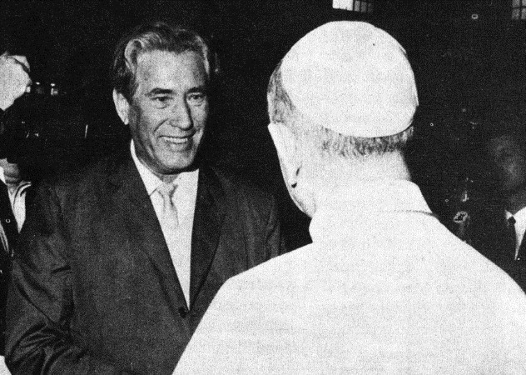

Friedrich Jürgenson and Pope Paul VI

It all started in 1959, in Nysund, his beautiful country estate near Stockholm. While recording bird chirping for a documentary, Jürgenson found voices in his recordings that identified themselves as the dead. He recognized one of those as his late mother’s voice, calling him by his pet name, Friedel. Others followed, including practically all of his dead friends. To my knowledge, this was the second case of spontaneous self-identification by the dead through EVP.
But the most relevant of all the occurrences in the great pioneer’s work, were the series of tests Professor Hans Bender carried out with him and the voices he obtained at the Freiburg Institute and the Northeim Institute directed by a ‘genius’, the theoretical physicist Burkhard Heim. As it is well-known, Professor Hans Bender was one of the most eminent parapsychologists of the 20th century. He tested Jürgenson on several occasions and also at the Freiburg Institute.
Scientists from the Max Planck Institute also got involved in the voices' research.

In his paper “Zur Analyse außergewöhnlicher Stimmphänomene auf Tonband. Erkundungsexperimente über die Einspielungen von Friedrich Jürgenson", initially published by the Zeitschrift für Parapsychologie und Grenzgebiete der Psychologie, Year 12, Nr. 4, 1970, pp. 226-238, Dr Bender (3)

describes some of the meticulous experiments he designed for Jürgenson (see English translation in the ITC Journal, 40, 2011, pp. 61-79).
The following summary in English was inserted at the end of the original article in German:
“Summary

The analysis of extraordinary voice-phenomena on tape recordings. Pilot studies on the «play-back-phenomena» of Friedrich Jürgenson. Since 1959 the Swedish painter and film producer Friedrich Jürgenson reported extraordinary voice-phenomena on tape; he was the first to expose such findings. He interprets these voices as "messages from the dead". As an initial approach, the Freiburg Institute in 1964 made an exploratory experiment to determine whether the voice phenomena were normally explainable or evidence of paranormal effects. A second examination with better technical equipment in May 1970 made the paranormal hypothesis of the origin of the voice-phenomena highly probable. The analysis of the sounds with Visible-Speech-Diagrams proved to be very helpful for the objective documentation of the supposed meaning”.
I quote further from Dr Bender’s paper:

“In summer 1964 the Freiburg Institute, together with Jürgenson, ran the first exploratory experiments in the private institute 'Deutsches Institut für Feldphysik' ('German Institute of Field Physics') in Northeim. Involved from the Northeim Institute were its head, Dipl.-Phys. B. Heim, and his audio engineer W. Schott, H. Bender and philosophy student G. Vilhalmsson from Freiburg and, as an observer, the physicist Dr F. Karger from Munich”. The strictest controls were implemented by Hans Bender and his team over the several tests done with Jürgenson during which anomalous voices were recorded.
Bender avowed: “There was no doubt that on completely new tapes which excluded fraudulent manipulations – and that was, anyway, extremely improbable considering the honourable character of Jürgenson – acoustic occurrences happened, the origin of which could not be determined”.

And he continued:

“…. In collaboration with J. Sotschek, member of the research team
'Acustik' of the Telecommunication Techniques Central Office, Berlin, and author of the following (4) article, audibility measurements were performed with 5 'recordings' (TANNER, TANNER; VON WO; ABER ZÜSS; RASMUS and STOP –
AS YOU LIKE ONE PAUSE). The Experimental 'listeners' were 7 members of an 'audio squad' collaborating with the research team and 6 'listeners' without experience in speech discrimination measurements. Language skills in English existed at different levels”.
The Visible-Speech-Diagrams required by Bender to objectively decide on the interpretation of the voices, were performed by J. Sotschek, the top German acoustic technician above mentioned.
Jürgenson was uncompromising in his conviction that the voices were messages of the dead. Many friends and relatives, as well as his own mother and his ‘liaison assistant’ Lena, a deceased friend of his youth, identified themselves in his recordings. AUDIO 1 SO KALT IST IN DIR.
Nevertheless, as should be expected, Professor Hans Bender did not specifically endorse the deceased as the source of Jürgenson’s voices but he fully accepted the paranormal origin of the latter.
Friedrich Jürgenson devoted the rest of his life to spreading the word about “the voices of the dead”, a happening of such magnitude that he thought could revolutionize the world and the prevalent human paradigm (23).
Samples of Jürgenson’s voices at: www.leopoldreport.com/FJ- voices.html

Raudive, the great systematizer of the electronic voices

But it was one of his disciples, perhaps the most distinguished one, a Latvian psychologist, student of Carl G. Jung, with extensive published work to his credit, who raised the study of the electronic voices to the status of preliminary science. Dr Konstantin Raudive, himself a successful experimenter, popularized

the method after the introduction in England of his book Breakthrough: An amazing experiment in electronic communication with the dead (1971). The launching of Breakthrough was in itself an odyssey.
The publishers, Colin Smythe and Peter Bander, author of Carry on talking: How dead are the voices? (2), saved no effort to demonstrate the authenticity of Dr Raudive’s claims that he recorded the voices of the dead. Because Raudive’s voices yielded personal identification from the deceased, also. In some cases, they provided names and other pieces of information about their past lives as the author methodically describes in Breakthrough (35). Some remarkable examples are reported by Dr Peter Bander, also. On page 25 of his book, Bander comments “Among Raudive’s thousands of voice samples are some which develop special mention; they are different from the others, not only in clarity but in speech content. The outstanding voice among those is that purporting to belong to Margarete Petrautski. It has been recorded in different countries without Raudive being actually there. She was a close friend to both Raudive and his wife, Dr. Zenta Maurina, and acted as secretary to them. Almost immediately after her death, a voice was recorded calling out “Zenta” – there followed the name Margarete and the remarkable statement “Bedenke ich bin” (German: “Imagine, I really exist” or “I really am”). I was so impressed by this voice that I first rejected the title Breakthough for the book and suggested “Imagine, I Am” … (2). AUDIO 2 RAUDIVE FROM BREAKTHROUGH, ZENTA, ZENTA!
In his very interesting book, Bander tells about Raudive’s vicissitudes and the dramatic journey that finally made the publication of Breakthrough possible. He describes in great detail the labour of verification that the most knowledgeable sound technicians in the UK went through to validate the paranormality and the interpretation of the voices Dr Raudive presented. The former included Ken Attwood and Ray Prickett, chief engineers at Pye Records, Ralph Lovelock, electronics engineer from Belling and Lee Ltd., David Stanley, the publishers, and others. The recording experiment in a Radio-Frequency-Screened Laboratory of Belling and Lee at Enfield was highly successful (Bander (2), p. 57). In effect, the strictest controls available at the time were implemented for the testing of Raudive’s voices, a demand of the publishers (Bander (2), p. 64) to carry out the publication of the book. Peter Hale, one of the five leading experts in the

West in screen-suppression, declared about Raudive’s results in the screened laboratory “From the results we obtained last Friday, something is happening which I cannot explain in normal physical terms” (Bander (2), p. 66).
On a couple of occasions, Peter Bander himself experimented with the EVP method with success. The experiment he describes in his book yielded personal identification of deceased individuals, also; in this instance, his father and his mother whom he had decided to consult while pondering the difficult decision about the publication of Dr Raudive’s book in English.
I cite from Carry on Talking; “I actually said during the recording: I will give father ten seconds and mother twenty seconds to answer my questioning because my mother would anyhow talk more. – I then addressed myself to my father and said: Father can you help me? (in English). I waited ten seconds and then I said: Mother, you know what I have to do, am I right in doing it? I waited twenty-five seconds and then switched the recorder off On playback,
watching the revolution counter on the tape recorder, I heard within a fraction of the first revolution a man’s voice. After only three playbacks, the contents were quite clear to me. The language used was a dialect in which my father used to speak to his intimate friends and although neither my mother nor I ever spoke it ourselves, we understood it; “Jung, wenn ich doch nur kuennt” (meaning: Boy, if only I could). The interesting word is “Jung”. This was indeed the way my father used to address me when he was alive.
Then came the turn of my mother’s answer; again within a fraction of a second after asking my question, the answer had manifested itself. “Und trotzdem sagst Du nein” – A literal translation would mean “and you still say no” – However, seen in context and knowing my mother’s way of speaking, I prefer to translate it: “Whatever I say, you still will do the opposite” (2) p. 35). Not a definitive reply - those are rare in ITC albeit with exceptions- but still a personalized reply.
In the course of his research, top scientists gathered around Dr Raudive and contributed to the understanding of the process and to the betterment of his devices. Among them, Professor of Physics Alex Schneider of St Gallen University, Prof. Dr Gebhard Frei, Theodor Rudolph, Engineer in High Frequency Techniques, Dr Ing. Franz Seidl, who invented the Psychophone, Prof Dr Hans

Bender, to cite some of the most prominent ones. Their knowledgeable comments are included in the Appendices to Breakthrough (35). We should keep in mind that these were personalities of high standing in the scientific circles of their time, and they would certainly not risk their reputation by supporting and collaborating with somebody whose work and results they did not deem worthy.

George Meek and the Spiricom

A visionary from the USA, George Meek, engineer and successful business man, endeavoured in the quest of establishing direct communication with high entities from other dimensions of existence.
He founded the Metascience Foundation and seemed to partially attain his goal with the cooperation of William O’Neil, an electronics engineer, healer and medium of controversial reputation for some. The famous Spiricom is reportedly the result of instructions from a deceased NASA scientist, Dr George Jeffries Mueller. Allegedly, several hours of dialogue were obtained between O’Neil and Dr Mueller. Nevertheless, in many circles the results remain debatable due chiefly, I believe, to O’Neil`s malicious critics who, however, have not proven their allegations. On the other hand, they do not mention the difficult, painstaking actions that had to be taken to confirm Dr Mueller’s identity. Above all, George Meek’s amazing finding of the manual Introduction to Electronics written by Mueller, which he informed about during his conversations with O’Neil (Fuller (18), pp. 184,185).

George Mueller communicated via ITC in Germany and Luxembourg

Since we are discussing the Spiricom, it seems pertinent to report on Dr George J. Mueller’s contacts with Adolf Homes via DRV, TV images and computer texts. (Senkowski (40) pp. 328-336).
The German physicist Ernst Senkowski reported, “In 1991, a picture of him (Mueller) appeared spontaneously on HOMES’ TV set. More than one year later, a series of spontaneous messages via radio came through”. A great number of those and several computer texts were addressed to Dr Delavre and

Dr Senkowski who closely worked together for many years. They replied to questions put by the two researchers to the deceased NASA scientist (Senkowski (40) p. 62; pp. 328-336).
Together with the Luxembourg couple, Homes, a modest carpenter, was one of the most impressive ITC operators. He received a wealth of over 200 spontaneous digital texts on the screen of his computer. They informed on existential issues of paramount importance to humans from the concept of God, ultimate reality, free will, the next world and many other questions including how human behaviour on the Earth should develop. Replies to the questions addressed by Senkowski and other scientists to Homes’ communicating entities were also received on the computer screen of the German operator.
Going back to the accusations against O’Neil and the Spiricom, one of which pertains to the impossibility of replicating the results of the latter, I recall that according to the information conveyed by the entities and published by Senkowski in his Instrumentelle Transkommunikation (40), the replacement of an ITC operator on the earth by another person is not possible because the oscillations (vibrations) between the communicators and the new experimenter would not match. They form the so-called contact field indispensable for the achievement of the contacts. Seemingly, this requisite would explain the failure to replicate the Spiricom after O’Neil’s death and similar cases, such as Peter Härting in Darmstadt who, for some time, received messages from a high non- human entity who informed that it could be called ABX Juno. The contacts ceased after Härting’s death (37); (40).

Similarities between Rio do Tempo and the Spiricom voices

I found a few matching situations between some characteristics of the voices produced by the Spiricom and the ones recorded in my own experiments. The screeching noise made by the Spiricom carrier was similar to the background noise produced by my communicators through the radios on several occasions. Noises that Maggy Harsch described as being similar to “an electrical saw” were reported in Luxembourg, too (Locher and Harsch (30), p. 116).

Moreover, the robotic style of the Spiricom voices is similar to some of my communications from Rio do Tempo station. Robotic voices were received in Luxembourg as well, particularly the one used by the famous high entity that the experimenters called the Technician (Locher and Harsch (30), p. 143). Also, Dr Mueller warned that he “was leaving” and my main communicator, Carlos de Almeida, did the same (5). Furthermore, the sudden disappearance of the voices while communicating, something I also experience.

Professor Ernst Senkowski

It is time to introduce one of the most important figures in the field of ITC study and research. A German physicist, Professor of Physics at the University of Mainz (Electrical Engineering Department), Dr Senkowski was one of Europe’s and the world’s leading authorities on all aspects of the subject. He coined the term ITC for the wide range of electronic anomalies known as EVP until then.
Himself a successful experimenter, Dr Senkowski devoted his life to the difficult task of trying to understand ITC phenomena. In his own words, “ITC can be described as an extraordinary interaction of mind and matter presenting evidence of conscious personal life after death”. (Senkowski (45), p. 258).
A physicist and a radio ham who doubted Jürgenson’s affirmation when first acquainted with the phenomenon in 1974, Professor Senkowski decided to personally experiment in EVP and perhaps his positive results much contributed to his overwhelming dedication to this method. I quote from his writings again, “When I first began my own experiments into ITC at the end of 1976, I immediately detected anomalous voices insisting that the dead are alive and able to think and speak. Two weeks later my deceased father spontaneously addressed me in his original German dialect, using my boyhood nickname. In 1989 I published the results of 12 years’ intensive work in my book Instrumentelle Transkommunikation….” (Senkowski (44), p. 155).
His monumental work is the most reliable and comprehensive compilation of ITC events since the very beginning of the discipline. Therein, Dr

Senkowski puts forward working hypotheses to interpret the phenomena he witnessed personally all over the world. However, he also recognizes the impossibility of attaining the goal because the different physics extant in both dimensions render the task practically impossible. Although several other scientists witnessed their communications, Professor Senkowski closely followed the contacts received by the most important operators in the field - the couple Maggy and Jules Harsch-Fischbach (H-Fs) of Luxembourg and Adolf Homes of Rivenich, Germany, as we will see later. He was a preferred interlocutor of the communicators with whom he repeatedly interacted.

The spreading of the voices

Many ITC operators, mainly in Europe and the USA, followed the path initiated by Jürgenson and Raudive and attempted the electronic contact with the dead, apparently with good results.
In the US, Sarah Wilson Estep (13) founded the American Association of Electronic Voice Phenomena, which she presided for many years. In France Monique Simonet (47), also a school teacher and a writer like Ms Estep, founded the French Association Infinitude. They both obtained EVP voices of good quality and in the case of Mrs Simonet, images of some of her deceased family members, too. In Italy, Marcello Bacci (1) became famous as a result of the Direct Radio Voices that his old valve radio produced, reportedly for some thirty years. Parents and other family members of dead people came from all over Italy and other European origins to speak with their beloved ones, seemingly with success. I was present at Bacci’s centre in Grosseto, Italy, on a couple of occasions and spoke with the communicators in Portuguese, a language nobody knew I was going to use. Reports were published in the ITC
J ournal nº 20, 2004, pp. 14-21; nº 25, 2006, pp. 23-33).

In Germany, people interested in the subject assembled into the VTF (Association for Transcommunication Research) to experiment with the EVP method. One of those was Hans Otto König, an electronics engineer and a controversial figure in the opinion of some who, nevertheless, seems to have produced excellent results for a number of years. He became celebrated for the

anomalous images and for a live TV program in Luxembourg when contact was established between a mother who had lost her daughter and the deceased child under the scrutiny of the TV technicians and Rainer Holbe (21), a German journalist, writer and researcher of the paranormal of good reputation.
At least two of Holbe’s several books, published in German, are entirely devoted to ITC, Fantastic Truths, Messages from the Afterlife (2006, Der Audio Verlag) and Life after Death (2008, Der Audio Verlag).
He closely followed the work of Klaus Schreiber, another important ITC worker and the initiator of the method to obtain the transimages. In another well- known work, Holbe described Klaus Schreiber’s accomplishments, as we will see next (21).

. The transimages

Klaus Schreiber, the precursor

In the mid-1980s, Schreiber, a retired fire protection technician, was allegedly instructed by his deceased daughter Karin with whom he had EVP contacts, to produce an optoelectronic feedback process to capture anomalous images (transimages) from her world. Through this method he obtained photos of all the deceased members of his family as well as of other personalities some of them famous. Rainer Holbe and EVP researcher, experimenter and writer Hildegard Schäfer2 visited him in his house on numerous occasions and witnessed the forming of the anomalous images on the screen (Holbe (21); Schäfer (37), pp. 251, 252).

2 A very knowledgeable German ITC operator who wrote several books on the subject which she thoroughly researched through her own and other operators’ experiences.

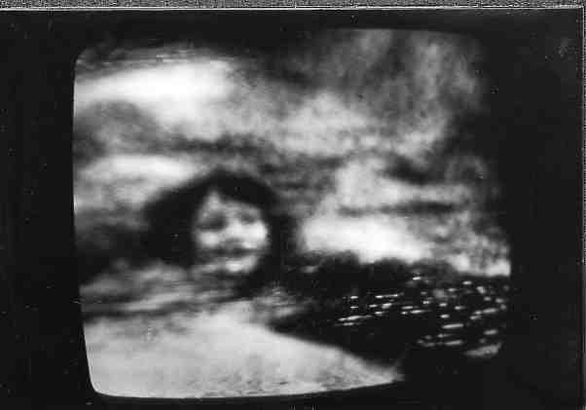
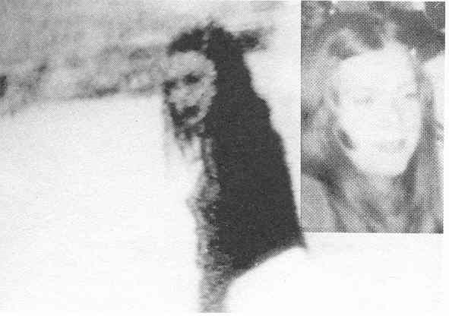

His daughter Karin who had died at 18 years of age (above and left the transimages, the living photo at the right (Holbe (21) German original p. 75).
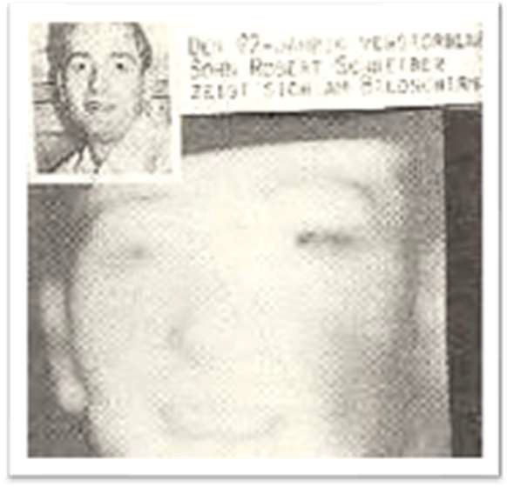
His son Robert Schreiber, real life photo on top (Holbe (21) German original p. 93).
It came to be known as the ‘Schreiber method’ and has been used by many ITC operators all over the world with positive results. These days, the TV screen and video recorder are no longer used and the experimentation is normally done with a video camera pointed at an ‘empty’ computer screen. A feedback loop is obtained through the filming of the screen by the video camera and its feedback to the former. A kind of ‘unstable’ light tunnel appears on the

screen and its reflection is fed back to the camera in a continuous optical loop between both.
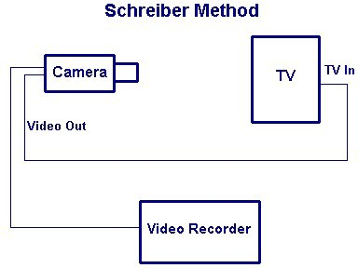

This was also the way I started experimenting in ITC, even before the EVP experiments, and obtained results. One of them, the mask, was announced by Carlos de Almeida through a DRV voice. The original image of the mask is below. Not very clear but it complements the masculine voice that announced a mask when I asked if I could expect to record the transimages. At the time, beginning of 1998, I and my very small group of three people (Fernández (15)) used rather anachronistic devices for visual ITC because we didn’t know more… And although the equipment does not make the contacts happen, it is important for the quality of the same.

AUDIO 3 MÁSCARA DE ESCULTOR

I stopped the experiments with the transimages because at a certain point, the quantity of anomalous voices I received was overwhelming and I

could not cope with both. I have always been more interested in the information provided by the voices and the experiments for the transimages are extremely time-consuming.
These days many ITC operators experiment with the Schreiber method and attain results. The difficult thing seems to be not to get results but to get results of such photographic quality that they can be effectively compared with the deceased beyond any doubt. Nevertheless, such situations, although rare, exist as was the case of many of Schreiber’s as well as the Harsch’s and Homes’ transimages.

Other remarkable ITC images followed

Shortly after Schreiber and via the sole action of the communicators directed by the Technician, an incredible range of anomalous images were received at the CETL. They comprised single persons and groups - relatives, Buschbeck, a famous ITC researcher, Deville, Raudive, Dr Swejen Salter, Richard Francis Burton, the famous English explorer, Rudolf Steiner and others, all deceased - and animated animals, river, forest, planet rise, starry sky, parts of a group of statues of medieval dancers in a Luxemburg theatre square, with slight deviations from the original: a mask, a bigger hand held fast by a smaller hand, and other pictures. It is important to note that some of these are not still images, they are in motion, e.g. cats drinking from a full plate, pigeons at a fountain, etc.

The concept of the bridge

It was Jürgenson who probably named the concept in the first place (23).
Later on, particularly during the golden age of ITC, by the mid-1980s, the communicators, some of them “high entities of non-human nature” in their own words, frequently used the term to designate special arrangements of electronic devices assembled under their direction. According to the German physicist Professor Ernst Senkowski, perhaps the greatest expert in the field, “they make no sense from the technical perspective of human knowledge”.

However, the communicators also emphasized that factors of a different nature e.g., the motivation, intentions, spiritual development of the operators and participants in the contacts, intervened in the making of the ‘bridge’ as well. In my own experiments, an anomalous voice, presumably of Carlos de Almeida, my main communicator, averred “I have already put the bridge!” (translation). AUDIO 4 JÁ PUS A PONTE.
But the famous bridges - in Luxembourg, the ESB, Burton Bridge, GA1- did not allow clear dialogues from the beginning. Interestingly, it was only when the very strange GA1 was put into action that proper dialogues developed in Luxembourg. Maggy Harsch and Dr Theo Locher, president of the Swiss Association for Parapsychology, co-authors of the book on the Luxembourg contacts from which I have been quoting inform, “It was around the end of the month of August 1986 that the GA1 equipment was perfected with the cooperation of the Euro Signal Bridge. The ESB contacts that preceded this happening allowed for dialogues only in very rare cases. The GA1 formula finally granted this possibility” (Locher and Harsch (30), p. 121).

T he great ITC operators, Maggy Harsch-Fischbach and Adolf Homes

Maggy Harsch-Fischbach, a school teacher of Luxembourg, with the support of her husband Jules Harsch-Fischbach, a lawyer who worked for the Luxembourguese Government, experienced what were perhaps the most dramatic of ITC events ever. Extraordinary communications, which took an amazing variety of forms, happened at their home in Hesperange. Telephone conversations with higher non-human beings and deceased humans, DRV contacts that conveyed mindboggling information, transcendental images of landscapes of the next world and of beings of supranatural nature, as well as of deceased humans and animals, fax and computer messages with texts on existential and scientific issues, and replies through the same media to queries put to the entities by scientists and participants in the reunions, were a daily feature of their lives.

Besides Professor Senkowski, who actively participated in the Luxembourg experiments, other scientists and eminent psychical researchers and journalists from all over the world attended their sessions.
The Luxembourg events are so complex that even to describe them is a painful task. Perhaps the reason is what the deceased Konstantin Raudive put forward in one of the numerous messages addressed to the German physicist:
February 8, 1987, ESB: Dear colleague SENKOWSKI. You know, natural s cience is sceptical; of course also the majority of the men in the street.
N owadays naturally all, from infancy onwards, have been confronted with a m aterialistic view of life. Of course, it is so: new ideas are adopted by most
( people) only if they recognize them (as) fitting their worldview. Our task shall
b e to widen the worldview, to create a new one in which many truths will have a p lace (Senkowski (40) p. 302).
The German physicist informs about the participants in the Luxembourg sessions, “Among the well-known and well-informed observers were George W. Meek (USA), The Rev. Prof François Brune (France), Prof Dr, Dr Andreas Resch (Austria), Dr Theo Locher (Switzerland), Tina Laurent (England), Sarah Estep (USA), Prof Walter Uphoff (USA), Burkhard Heim, Dr Ralf Determeyer, Jochem Fornoff, Hildegard Schäfer (Germany) and physicist Ron Bryan (Great Britain). In many cases the visitors received personal messages and were able to conduct fluent conversations with the communicators”.

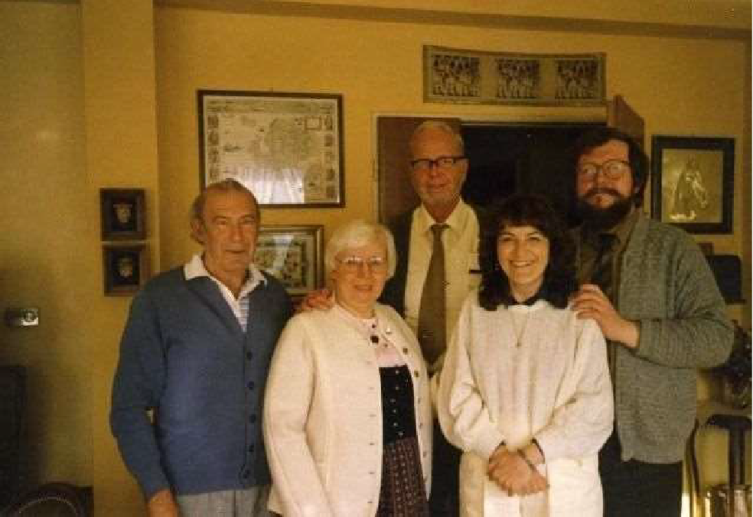

Ernst and Adelheid Senkowski with George Meek and the Harsch- Fischbachs in Luxembourg, May 1987

Given the magnitude of the phenomena experienced, the operators founded the CETL (Centre d’Études de la Transcommunication du Luxembourg) that regularly published some of the most striking events that occurred therein.
I will report the case of an extraordinary message received in Luxembourg via the ESB on 2.5.87, which George Meek witnessed together with seven people:
M y name is Henry Sainte Claire DEVILLE. I left your world in 1881, and I
a m speaking to you in my name and in the name of our staff from LIFELINE the s cientists. Your projects as well as from LIFELINE and from TIMESTREAM is to s et fire to minds, to set fire to minds in your world, and in that moment to try to
m aster time, I can give you a few explanations. The void dreams the universe,
b ut the void is unconscious. Universe has consciousness and it can control the v oice. A strong force, the inertia of normality, reigns the universe. So the
u niverse always chooses the same state as before, it sustains itself, it limits i tself. I repeat: the universe is dreamt by the void. It is varied out of grains,

g rains of virtual existence, grains called selectons. Selectons are really tiny dots c onsisting of a circle rolled up compactly. Forever they roll back into the void,
f orever other bits of void roll back to replace them exactly. All these selectons
r olled up compactly in the same direction, thus time flows in one direction in the
u niverse. In our space selectons are not rolled up, so there in the Never‐Ever all t ime is one and timeless.
Professor Senkowski kindly offered me a copy of the tape he presented at an SPR conference in London in 1996, which I have digitized to show here. Among other anomalous voices received by different excellent ITC operators, it includes Deville’s voice. Notwithstanding the disruptive Euro Signal whistle in the background, the anomalous voice is understandable as is the very high- pitched Technician’s voice. AUDIO 5 DEVILLE
Professor Senkowski was present during the transmission; he adds, “Investigations showed that drop‐in communicator DEVILLE, unknown to all those present, had been an excellent French chemist of the 19th century who, among others, was the first to study the properties of crystalline silicon. The year 1881 as that of his passing is correct” (Senkowski (40) ibid, p. 306).
I had the privilege of receiving from Dr Senkowski, as a gift, a tape containing one of the latest communications from the Technician, received in Luxembourg on July 20, 2000. It is spoken in three languages - German, English, a few words in French and to my great surprise since Dr Senkowski did not tell me beforehand about this, it mentions my name, also. It is a totally clear recording; I append the transcription and the translation into English. AUDIO 6 TECHNICIAN
At the Harsch-Fischbach’s, the mindboggling content of the information imparted by higher spheres of existence via different electronic media is unmatched except, perhaps, for the computer texts received by Adolf Homes.
Since it is extremely difficult to separate the work of the two operators because it often interacts, I will mention both, sometimes simultaneously, as I will do with the different media used by their communicators to convey their messages – the DRV, computer texts and images - which frequently also mingle.

. Computer texts

Adolf Homes’ and Maggy Harsch’s computer texts

The first recipient of anomalous computer texts seems to have been Manfred Boden in Germany, in 1980. Boden also experienced terrifying paranormal telephone calls. Ken Webster from England started receiving strange computer texts in 1984, allegedly from a historical deceased personality of centuries before, accompanied by frequent poltergeist activity. Professor Senkowski describes both cases as real.
Yet, the content of the messages Boden and Webster received cannot be compared to the messages received by the Luxembourg operators and very particularly by Adolf Homes (Senkowski (45), Cardoso (9)). In this context, I would like to again quote Dr Senkowski, “The work of Adolf Homes and of other global operators supports a spiritual world-view that partially resembles the post-modern theories of consciousness-physics. ITC can be described as an extraordinary interaction of mind and matter presenting evidence of conscious personal life after death” (45), p. 258.
The German operator is certainly the most paradigmatic of all ITC workers in this domain. He received anomalous computer texts containing information on practically all significant aspects of life. Many were spontaneous while others replied to questions put by the operator on behalf of, or directly by, Professor Senkowski, Dr Delavre and Dr Ralf Determeyer to cite the researchers who most assiduously witnessed and investigated Homes’ contacts.
An excerpt of one of the former, this time about the role of love, reads: “Love is the root of everything that exists. Life is love. Love is life forever, a consolation for men. Love is the purest form of energy. It is a single information center. Love is to be found in information. The real meaning of information is still difficult for you to understand. Love and unity are important concepts. Love is a supradimensional concept, which for you is only roughly correct. In love and again in love is the fundamental law that presides over all that exists. The

Natural Law is love. Love is a multidimensional aspect of the divine power. All that exists is embedded in the big unconceivable love of the Great Spirit in the eternal river of the whole being. Only love is able to surmount space and any time. To know love opens all doors. To recognise love in all things is the key to the Omnipotence whose love is far greater than we can imagine.
In the love for yourselves as well as for All-That-Exists, we find all the realisations of the Great Spirit. If you love every being as yourself, you are worthy of the Great Spirit and Creation. The love of the Omnipotence is in all things…” (Senkowski, German original, (42), p. 53; Cardoso (10)).
More than 200 computer texts were received at Homes’ computer in Rivenich. They were transcribed and published in the German original in the journal TransKommunikation, a special edition devoted to the work of Adolf Homes (Vol. IV, 1999). A translation into Italian is also available (Transcomunicazione, Numero Speciale, 1999).
The deceased Friedrich Jürgenson conveyed the following message through one of such texts (see below the image of the screen filmed by Adolf Homes with his video camera, which I received from Prof Senkowski):

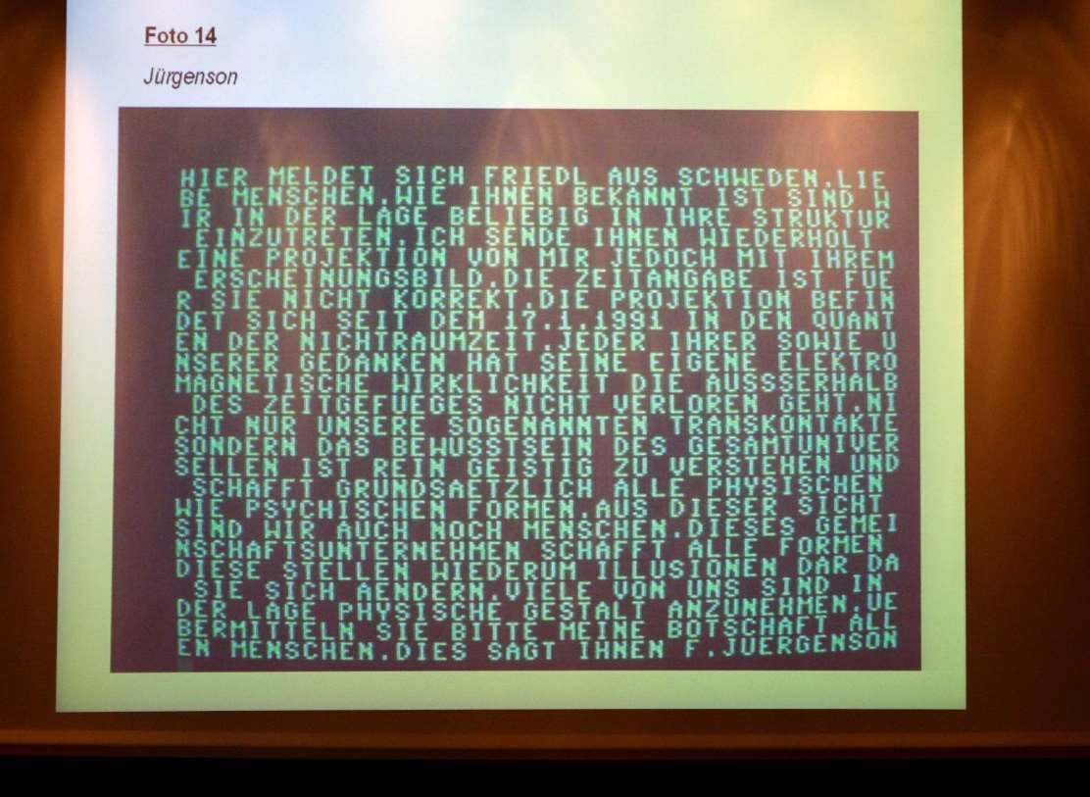

Translation of the German text:

Here, Friedel from Sweden is making contact. Dear humans. As is known to you, we are in a position to enter into your structure at choice. I send you repeatedly a projection of myself but with your appearance [the appearance known to you]. The time indication [on the video-camera] is not correct for you. The projection is in the quanta of no space-time since 17.1.1991. Each [one] of your and of our thoughts has its own electromagnetic reality that does not get lost outside of the time structure. Not only our so-called transcontacts, but the consciousness of the universal whole (des Gesamtuniversellen) is to be understood [as] purely mental/spiritual and in principle creates all physical and psychical forms. From this point of view we, too, are still humans. This collective undertaking creates all forms. These, in their turn, represent illusions, because they change. Many of us are in a position to adopt [a] physical shape. Please transmit my message to all men. This says to you F. Juergenson” (Senkowski,
(40) p. 213, 351; Cardoso and Senkowski (6), pp. 35-61; Cardoso (9), p. 47-48).

On the same occasion, October 13, 1994, an image of Jürgenson appeared on Homes’ TV screen simultaneously with the computer text in an adjacent room (Note: the computer switched itself on without Homes’ intervention).
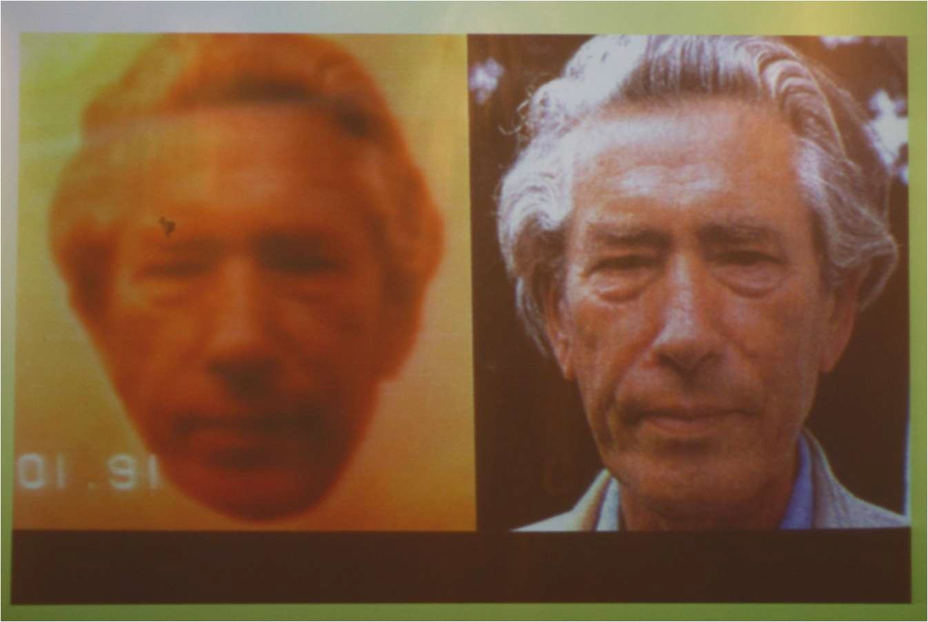
Left: the image which appeared on Homes TV screen Right: a lifetime photograph of Jürgenson for comparison

For us, it is certainly odd that the communicator refers to the electromagnetic reality of thoughts. However, we should not mistake the electromagnetic energy of the next world for ours. The communicating entities informed the following on the subject. I translate below extracts from the much longer original text;
“Spirit and matter are electromagnetic creations, everything carries the information Electromagnetic impulses penetrate all matter as well as all
universes. Light that cannot be measured by you does not consist of electromagnetic radiation. It has nothing to do with your electromagnetic waves. Our electromagnetic fields are not known to you. They are a range of radiant energies that do not exist for you and are not subject to absorption. Separate electromagnetic forms of energy will (in the future) coordinate with and take over the human psyche. We don't need any other electrical system because a computer is of subtle matter and consequently spirit. We don't need your electromagnetics to switch on your devices, because silicon, nervous cell and consciousness are absolutely the same thing for us. When we contact the Rivenich station, we will change the gravitational conditions known to you so that electromagnetic forms can be produced in the quantum vacuum, which reach all devices in Rivenich. A transmission from us takes place (i.e.) via quantum telecommunication ” (Senkowski, (42) p. 18-19).
Having no knowledge whatsoever of the area concerned, I am not competent to discuss the statements above. But Professor Senkowski (Department of Electrical Engineering) commented, “Herein under the general term of ‘Electromagnetics’, we find a series of clarifications which are difficult for us to comprehend. The statements that ‘Spirit’ and ‘Matter’ are information- carrying creations and that the electromagnetic fields of the Beyond are unknown to us, can still be acceptable – mainly the latter – if we consider the hypothesis presented by William Tiller or in regard to the hypothetical scalar waves that take as model Tesla’s ideas… I find the description of the
transcommunicative process as modification of the local gravitational fields more convenient ” (Senkowski (42) p. 19; Italian version (43) p. 41).
The examples above represent a sample of the anomalous information transmitted through computer texts, which contradicts our understanding of reality. Overall, the totality of the latter, with few exceptions, falls under this

qualification, i.e. the information received via ITC, apparently from higher levels of consciousness, is eminently anti-paradigmatic.
Another example, this time received in Luxembourg, is reproduced
below.

Computer text received from Zeitstrom station on 06.02.1988. Professor Senkowski transcribed it and I translated it into English;

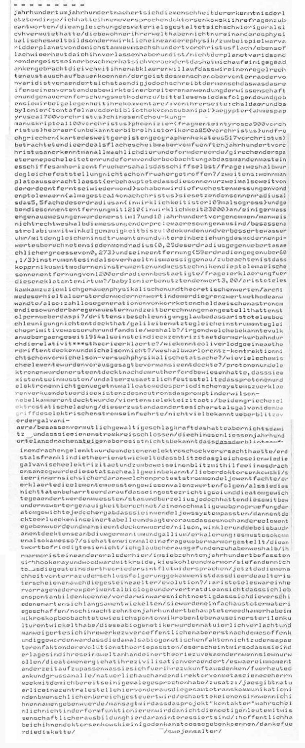

Guests: MEEK and author [Dr E. Senkowski]. Message from Dr Swejen Salter who informed that she was a deceased scientist from another physical planet. She frequently communicated with the Harsch-Fischbachs as well as with Dr Senkowski to whom she became particularly attached, and with other peers of the German physicist via the telephone, computer texts and the DRVs.
“ You can now look in the computer under WSMG.OVR. I repeat: W for Willi, S f or Susanne, M for Michael, G for Gertie, point, and then OVR. I entered
s omething there for you, Doctor SENKOWSKI. I greet you in the meantime”.

The text was displayed on the hard disk table of contents. It was called up on the screen and printed out.
Translation from the German original:

“ Century after century humanity gets closer to the understanding of the ultimate t hings!
I had promised you, Dr Senkowski, to answer your questions. The coordination o f the materials turned out to be more difficult than I had thought. The
i nhabitants of your universe have not only another physical view of the world, b ut also a completely different science of physics.
F or example, Varid, the planet where I am from, was flat six hundred years b efore Jesus Christ.
A s flat as it is round today, at least as it was when I left it! It was not the planet V arid that changed but the mind of its inhabitants. These observations have
g iven me some clues which I would like to examine with you so that we can h ave a real exchange of ideas!
T he spirit of man, come it from the Earth or from Varid, is in constant evolution;
T he process that causes this growth of his spirit, man attributes it to an
e xpansion of the application field of the sciences or to the deepening of the
m ethods of research. Please read the following and make your comments in
d ue time.

F rom your side: Chaldeans and Babylonians (clay tablets from the library of
A shurbanipal), the Egyptians (Ahmes papyrus, around 700 before JC), the

C hinese (Chou-Kung, manuscript dated from around 1100 before JC), the P hoenicians (fragments of Tyros of around 900 before JC), the Hebrews
( anonymous authors of the Bible of around 850 before JC), and the ancient
G reeks (chart of the great traveller and geographer Hecataeus, 517 before JC),
a ll these men considered the Earth as a flat disc) but since the V century before J C, the round shape of the Earth started to be gradually recognized. The
G reeks of the classical epoch deduced that the Earth should be round from an
o bservation: the mast of a ship could be seen in the horizon before the ship i tself! Question: why wasn’t this ascertainment made earlier?
S econdly: let us ignore Plato (he claimed that the sun was only twice
f arther away from the Earth than the moon). We have the oldest measurements o f the Ptolemies (Almageste, around 14 years after J. C.). They submit that the r adius of the sun is 5,5 times larger than the Earth’s (in reality it is 109 times)
a nd they establish the distance of the sun at 1210 (against 23.000 in reality).
T he first measurements relatively exact date from the XVII-XVIII centuries. It is n ot well known why the Ptolemies measurements were so imprecise. They
p ossessed an astrolabe with an angular precision of until ten seconds and a
p erfected clepsydra. With these same instruments and considering the modern v alue of Pi, they were able to calculate the radius of the moon (they found 0,29
o f the radius of the earth vis-à-vis 0,273 in reality) and its distance (59 times the r adius of the earth vis-à-vis 60,1/3). Therefore, their instruments were relatively
p recise. We note that Copernicus, in spite of modern instruments and
m easurement techniques, confirmed the distance of the sun by Ptolemy of 1200
r adiuses of the earth. Question: how to explain such an obvious error? The
B abylonians utilized a ratio of 3,00. Aristotle came up with fairly accurate
p hysical and theoretical values / Archimedes was the first to get the modern
v alue, in which he applied the limit value method / So: countless generations of correct Chaldean astronomers who had done such wonderfully accurate star and time calculations stumble about the Pi? / Third: Acceleration: Believe that Aristotle did not discover acceleration / Galileo used the same instruments, same primitive water clock and found it / Why? /
Any known Vulcan transitions since 1914, when Einstein explained the eccentricity of Mercury's orbit through the theory of relativity? / How could Oliver

Lodge discover an ether drift and Michelson not? / Why wasn't Lorentz contraction before Michelson? Physical fact experiment? / How many chemical elements were predicted before they were discovered? / Protons and electrons were only discovered after Rutherford proved that they had to exist / And when he also found that protons and electrons were not enough to explain all atoms of the periodic system, he proclaimed the existence of the neutron, which was promptly discovered in the Wilson cloud chamber / Fourth: Electricity: Among the Greeks: Electrostatic charge / This state changed only when Galvani introduced the concept of electric current / Not much known about lightning before the Galvani era / Presumably possessed tremendous power. But that had nothing to do with making a circuit.
Chinese kites have been flying for centuries, but lightning is not known to have been directed at a kite and cause an electric shock / Not until Franklin developed the theory that lightning was the same as galvanic electricity and for proof attracted lightning with the help of a kite, and this fact became generally known.
Dear Dr. Senkowski: You probably remember the stream of protest Mendeleev kindled / He explained that the elements had to follow certain valence values / When they did not, he insisted that his law was correct and that the atomic weights had to be changed / Stas and Berzelius, however, had calculated these with admirable accuracy / A further check of the atomic weights, however, showed / that they fit into Mendeleev's system / Then he discovered gaps in his table and predicted that there would be other elements and that they would be discovered / Nilson, Winkler and de Boisbaudran discovered scandium, germanium and gallium / Explanation: It had to come that way, so it came that way? /
You once asked a question about marble / You didn't get the answer / I think I figured out why / Your marble is different from the one here/
In the seventeenth century Hooke, Ray and Woodward dealt with chalk, gravel and marble / They did not find the rocks to contradict the theory of the Flood / Now that humanity from Terra has come to the conclusion that the earth is older, the rocks also seem older /

Evolution? : Aristotle was an excellent experimental biologist and he was of the opinion that life could form spontaneously / Before Darwin it was not necessary for the different species to evolve slowly / They were simply created from dead matter/ As recently as the eighteenth century, Needham claimed that he had observed under the microscope how micro-life spontaneously developed from a sterile culture / These abiogenetics were of course laughed at and their works refused publication / but only when after it had become evident that the abiogenetic facts at the time did not match the later facts of the theory of evolution / It seems to me that you are in a position to apply a theory to your world of being and change if you only want to / Atomic energy has changed your civilization / It is time to be careful now about what you come up with for your future /For today thanks and greetings to everyone / Of course also to the director of Metascience, Mr. Meek, with whom I've already spoken a few times /
Supplement in reply to a question by Professor Senkowski:

“ Yes, naturally there is a central office here, from which all
t ranscommunication in the human sphere is controlled / There would be no
p oint in giving you names / I am told that the "Kontakter" project will probably
n ot work as it should because the necessary people with scientific training are n ot interested in it / I hope I have given you, Dr Senkowski, some food for
t hought / Thanks for the diskette /Swejen Salter”.

The following statement fits ZENTRALSTELLE: “Higher beings/entities i mpart the permission for contacts. As well as the phrasing: We are informed
a bout everything, and in case we deem it necessary, we will inform the humans;
And: These questions will be answered when it is time. SALTER: (This
c omportment) made me suppose that beings/entities like the TECHNICIAN, and o thers, seem not to be prepared to disclose to us the project ‘Kindergarten’ in its e ntirety”. According to a message received from SALTER in November 1994, the project mentioned, in its hitherto form, was to be stopped” (Senkowski (40), pp. 310, 311).
The obvious danger when people in general get this type of information, is that not only they do not believe it but they dismiss it as rubbish. Because it dramatically opposes the human views on life and the world. However,

obviously, that is not a reason to dismiss the information as untrue... The voices and computer texts, as well as the images, were witnessed by scholars from different levels of knowledge that interacted with the communicators and testified for the honesty of the operators and of the situations.

T he Cross-Correspondences

As we have been seeing, many surprising occurrences took place both at Adolf Homes’ and in Luxembourg. I transcribe an extract from an interview with Dr Senkowski.
“Several cross-correspondences happened, for instance, messages in Luxembourg and Darmstadt and in Rivenich. In one case Dr Delavre [Dr Senkowski’s close collaborator] had noted a number of questions on a sheet of paper that he wanted to send to Homes. Thinking they might offend him (because of religious differences) he tore it to pieces and threw them into the wastebasket. Then he posted another list of questions. Surprise! The 'entities' answered part of the first collection of questions. To be sure that it was so Delavre assembled the pieces of the paper he had torn up” (6), pp. 38-39.

A few examples

“On June 12, 1992, pictures of ITC pioneer Friedrich Juergenson (V1987) were received in a computer in Luxembourg (Figure 1) and on a TV set in Rivenich, Germany (Figure 2). Following are excerpts from a message that accompanied Figure 1:
A ll thoughts are basically nothing but telepathy. In our view the human
e ye is blind, for it prevents the recognition of existing possibilities and
e xtrasensory perception . . . Our message is to tell you that your life goes on.
A ny speculations on how an individual will experience it are bound to be limited
i n validity. All your scientific, medical or biological speculations miss the mark of t hese realities. What serves as "real" to science is not close to reality in the
b road picture. It is no more than a word in a book. . . Thoughts have no limits.
O ther dimensions and structures of being unknown to you are able to capture

y our thoughts and our thoughts telepathically. -- Friedrich Juergenson 1992- 06- 1 2.
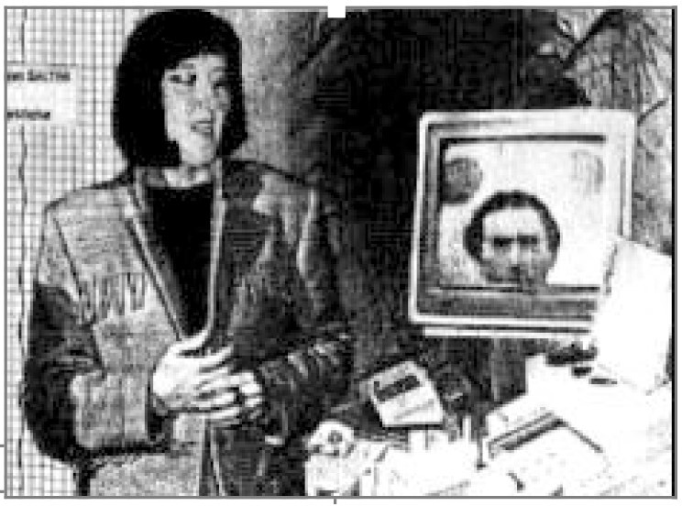

Fig. 1

Two similar pictures were received at different ITC stations on the same day. The CETL team of Luxembourg found Figure 1 in their computer. It shows spirit colleague Swejen Salter preparing to send an image of F Juergenson to a television on Earth. Figure 2 was received on the television of Adolf Homes of Germany. Both pictures were received at approximately the same time. (Pictures courtesy of CETL and Adolf Homes, respectively.)

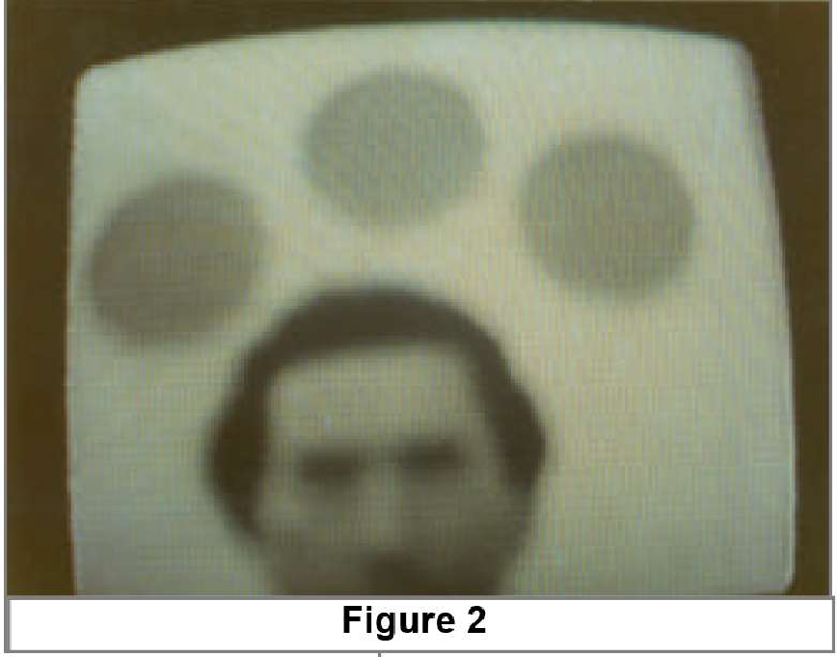

Meanwhile, experimenter Adolf Homes of Germany was notified by spirit colleagues on 1992, April 28, that they would try to send him a video image of Friedrich Juergenson in the near future. Two months later Mr Homes had forgotten about the message. On June 11 he was out of the house. His daughter Karin received a phone call from spirit colleague Konstantin Raudive, who announced that a video transmission would be attempted the following afternoon. On June 12, after lunch Mr Homes set his camcorder up in front of his old black-and-white TV set, and made recordings all afternoon. The image of Friedrich Juergenson (Figure 2) flashed across the TV screen for 0.7 seconds, and was captured on tape. Mr Homes' black-and-white TV has no antenna connected, no cable connections, and is left tuned to an empty channel” (Contact, Volume One, #96/01, p. 5).

“A Transatlantic TC Experiment

The second outstanding example, known as 'A transatlantic TC experiment', consisted of a number of interconnected stages, as explained in due course below.
On the evening of April 22nd 1987 (previous to the first of these stages), George W. Meek from Franklin, North Carolina, USA, the former promoter of

the Spiricom transcommunications, while unaware of the telephone number of the H-Fs, informed me by telephone that the transgroup Lifeline, with which he was in touch through a medium, had announced that they intended to contact the H-Fs in Luxembourg via Zeitstrom (Timestream), the following day at a pre- arranged time. I left a message to this effect on the H-Fs’ answer-phone, and shortly afterwards received their reply that they were willing to participate in the
experiment. Subsequently, at 7 p.m. on April 23rd 1987, they reported the
successful outcome in Luxembourg, which involved four distinct stages.

- The Technician announced the existence of the experiment in German, and then handed over to the transgroup Lifeline.
- Maggy H-F then conversed for three minutes with Lifeline communicator Nelson D. Rockefeller in English, a conversation that was interrupted several times by a normal radio transmission on 90 MHz.
- The Technician then closed the contact, speaking in German.

- On the suggestion of the Technician, Maggy H-F informed Mr. Meek and myself by telephone of these results.
In this really spectacular case we are confronted with a complex holistic process, partly telepathic (mediumistic) in the USA, partly instrumental in Luxembourg, and supported by several technical telecommunication links. The experiment constitutes a documented objective verification of the 'one-world- concept' and of the expanded quantum theoretical entanglement.

A Strange Cross-Correspondence
The third example occurred on June 19th, 1991. After the announcement
by the communicators of an imminent transcontact, the German ITC operator Adolf Homes, before leaving his home in Rivenich, switched on his receiving devices. On his return he found that these devices were switched off. The tape- recorder stood on end and contained a 10-minute recording of a message from a communicator using the name Hans Bender (a famous deceased Parapsychologist from Freiburg/Germany). In a subsequent telephone conversation with the H-Fs, Adolf learned (as he afterwards confirmed to me by

letter) that at precisely the same time, the identical message had arrived in Luxembourg on the PC, framed by two additional remarks from Homes' deceased mother Elise Karoline at Station Centrale. Only three unimportant differences could be found between the recording received by Homes and the computer text received by the H-Fs. The details of the messages, translated into English, are given below. First there is an introductory passage received only in Luxembourg, and then there is the (slightly abbreviated) identical message received both in Luxembourg by the H-Fs and in Germany by Adolf Homes. Finally, there is a postscript received only in Luxembourg.

Introductory Passage Received Only in Luxemburg

S tation Centrale to station Luxemburg 19-06-91 10:30 Elise Caroline
H omes greets all (those) interested from stations Centrale and Timestream. To
f urnish a further proof of our collaboration we transmit to you a text that this day h as been put through also to my son Adolf. I hand the device over to a
n ewcomer in our group.

Identical Communication Received Both in Luxemburg and in Rivenich (slightly abbreviated)
H ere is a contact from the deceased Hans Bender from Freiburg …...
Y ou are right in your decision to be sparing with publications since you are still a
t arget of ridicule for too many people Each of you receives those contacts
f rom us which we deem appropriate on the basis of your state of consciousness a nd the state/condition of your souls I am visiting Freiburg and am feeling
v ery well Very pleased was I when at my passing (among others) I noticed
R audive. I was even very pleased about a scientist deceased before me, who
d uring (his) lifetime had been an objector to our (post-mortem) existence. We
w ere opponents only on your side [i.e. on Earth] As to the immortal soul, so
w e tell you that it is present in the entire universe and can be everywhere at the
s ame time. It feels sadness and happiness as we do. But there are men who a re closer to their souls than others. We (the) dead aim at creating an

i nstrument by which positive men are enabled to contact our mental/spiritual
w orld. Please give my regards to Dr. Senkowski, Dr. Delavre, Mr. Meek, as well
a s to Dr. Determeyer and Mr. Steiner. Contact ended.

Only in Luxemburg:

H ans insists on saying that he regrets the matter/affair of Strassburg. He
h ad to experience personally what doubt can represent ... I close this contact.
E lise Karoline Homes.

C omment

Considering all the relevant circumstances we have to exclude normal explanations for the voice received by Adolf Homes and for the computer-text received in Luxembourg. A further two important considerations support the non-locality (and therefore anomalous nature) of these proceedings. Firstly, an astonishing phenomenon occurred in connection with Alfons Steiner, an Austrian parapsychologist, whose acquaintanceship with Bender was unknown to all the individuals involved in the above examples. When questioned by myself, Alfons surprisingly explained that in a conversation with Prof. Bender in
Vienna on May 29th 1984 on the subject of the continuance of life after death
and the reality of transcommunications, he had expressed his scepticism, to which Bender had responded by promising that 'if possible after his death he
w ould send him a sign of survival via a third party'.

Secondly, an impressive fact is the enigmatic reference by Bender in the postscript received only in Luxembourg to the fact that he regrets the
m atter/affair of Strassburg. Elmar Gruber, a former student of Prof. Bender who
wrote the biography of his teacher, told me that during his time in Strassburg Hans Bender had played a trick in order to 'prove' the presumed fraud practised by a volunteer. This unethical behaviour had almost cost him the support of his sponsor” (Senkowski (46)).

B ack to Luxembourg

The first image and sound transmission from the next dimension happened at the Harsch-Fischbachs’ on July 1, 1988. I translate from Professor Senkowski’s book;
“1.7.88. DETERMEYER picture tone contact. During the appearance of the image, which is reversed, similar to a photograph by Konstantin RAUDIVE during his lifetime, there were four linguistic blocks, separated by three pauses, each introduced and concluded by a clearly audible impulse. The partially defective SW-FS device was used without an external antenna. The recording was done with a separate camcorder. Signal-to-noise ratio about 20 dB. Understandability: 100%. A brief distortion in the last section heralds the end. At constant speaking speed, the decrease in speaking time and the number of syllables in the individual blocks indicates increasing contact difficulties. The quality of the still image received at the same time was excellent. Similarity (not: identity!) to a photo of RAUDIVE when he was younger.
G ood evening, dear friends - this is Konstantin RAUDIVE speaking. Dear
f riends, dear MAGGY, dear JULES, dear colleague DETERMEYER! I am p leased that you have come here again this evening. What you are
e xperiencing at the moment is a historical hour both on your side and here on o urs. It is the first time that picture and sound are transmitted and received at t he same time (pause 12 sec).
I decided to teach something to some who still have doubts, to pass on a p icture of myself, it shows me here where I am now on this side on the banks of t he river of eternity, as well as the people of good will who feared that I would
n o longer belong to the ZEITSTROM group (pause 6 sec).

D ear colleague DETERMEYER! Things like this, what you are
e xperiencing now, happen not only because we strive on our side but also b ecause there are people of good will on your side who are committed to
t ranscommunication (pause 7 sec).

Y ou yourself have made an exemplary effort to bring together ... (to)
f ound a world organization” (Senkowski (40), pp. 302-303).

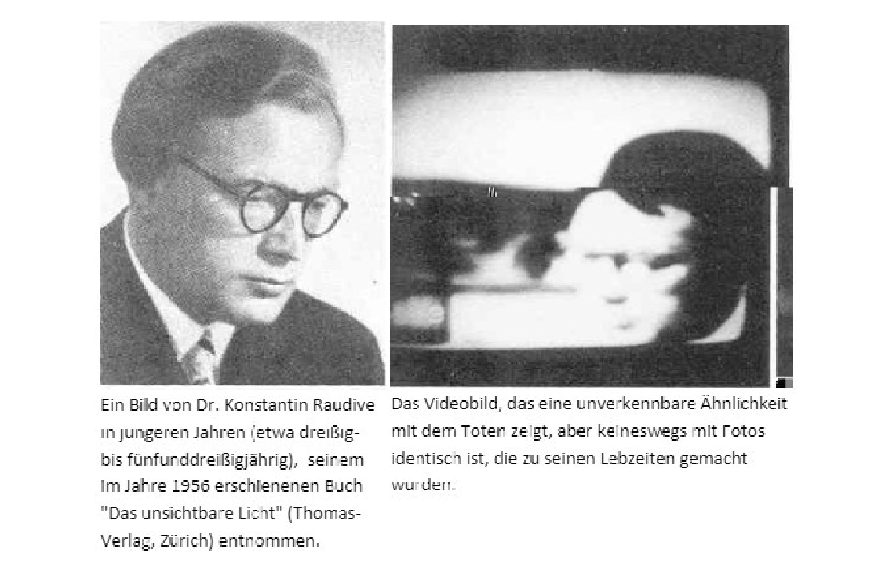
A photo of Raudive The transimage
in his thirties

Another incident from the many that occurred in Luxembourg, seems interesting to report about. This time, it was a moving letter addressed to George Meek who, by then, was back in the US. I transcribe from the CETL bulletin:
“Jeannette Meek died on April 2, 1990. As a well-known pioneer of ITC research, her husband George W. Meek of Franklin NC knew his beloved mate would make every effort to contact him through a very successful receiving station in Europe - the CETL Lab in Luxembourg. George took his last trip to Europe in July 1990 and spent a weekend with Luxembourg experimenters Maggy and Jules Harsch-Fischbach. He observed the assembly and operation of a new ITC system which employed electronics, ultraviolet light, and crystals, and the three friends reminisced about dear Jeannette. On February 21, 1991, George Meek was back home in North Carolina writing a letter to his friends in Luxembourg to ask if they had received word from Jeannette. That same day the CETL experimenters returned to their Luxembourg home from their full-time

jobs to find their computer running, and a new file on the computer disk. The file contained a long message from their spirit colleagues, including this letter from Jeannette:
Dear G.W.! I'd like to cook up a few good names for you believing I could have wings. I'm sure you recall I often have told you there are lots of things you come in handy for, not only to do (such as take caps off bottles) but also to tell somebody else just what to do (expert advice)! Well, it seems as if there are still people who do not believe in the contacts your friends here at CETL are having. Here are some details which except you and Molly (give her my warmest greetings, I miss her) nobody can know: In 1987, end of April, tenant Debbie called to say her refrigerator was off. It must have been on a Thursday morning and no connection with the storm we had before. At the close of her work day she called again to say she was having more trouble. This time she had left her purse on the seat of the car of the lady with whom she had been riding. This lady was quite far from Franklin so Debbie asked to borrow our key to her place. Another story: on April 29th, Ann Valentin wrote a letter saying that she had not received the Magic of Living Forever booklets they had ordered, but Harlequin novels. Third story: John Lathrop (I don't think Maggy and Jules ever heard THAT name!) shut off the electricity at the "C" house to put in the new light. He wasn't down there very long but charged $20 service in addition to $40 for the bulb itself plus tax (the scoundrel). Don't try to explain this, Honey. My never- ending love to you. I miss you so much, but I know we will be together. I have big work to do here. Result of that idiot war. Love forever. J. to M. Please Maggy, forward this to George. He can be of great help to you all. Send my best wishes to Loree also. Thank you. Jeannette Duncan Meek. End of contact.
Maggy called George and read the letter to him over the phone. George realized that the three items in the letter were known only to George, Jeannette and their assistant Molly, and he was struck with the realization that the message from his beloved wife was perhaps the best hard evidence ever produced that life continues after our short lives on Earth, and that ITC is legitimate” (Contact, 1996, January-April).

The attacks against the Harsch-Fischbachs

As it should be expected, all kinds of slander and fraud accusations have been cast, particularly upon Maggy and Jules Harsch-Fischbach and their fantastic ITC results.3 The attacks came not only from the sceptics but also from other ITC operators who, generally speaking, had achieved mediocre results in their tests.
It is true that the magnitude of the phenomena concerned is of such significance and impact that we can understand the motives behind the sceptical accusations, especially if we take into account the fact that the Luxembourg events started to happen by the middle of the 1980’s, a time when only Jürgenson, Raudive and very few others were known.
But there is another important factor that accounts for the reaction – some of the messages received in Luxembourg had their counterparts in our earthen world. Some of the texts and images conveyed by the Technician or Swejen Salter from Zeitstrom were very similar to texts and images extant in our world, albeit with minor differences. To start with, the description of the world of Zeitstrom (Timestream), from where the messages originated, is very similar to Philip José Farmer’s series of science fiction books Riverworld (14).
Dr Senkowski quotes the Technician on this issue “TECHNICIAN: I inspired FARMER, but his representations are not consistently accurate”. And the German physicist continues, “FARMER himself is not aware of any particular source of his imaginative narratives, especially of any inspiration. In contrast, the 'inventor' of the 'Starship Enterprise', RODDENBERRY, received a lot of his information in sessions of the English deep trance medium Phyllis SCHLEMMER (WIER GOWSKI in: 'Die Andere Reality', No. 5/1993)” (Senkowski (40), p. 387).
From her side, questioned by Professor Senkowski on the reasons for the duplications, Swejen Salter informed (extract):

3 Apparently because of the persecutions they were the object of, Maggy and Jules Harsch- Fischbach have since stopped their ITC experiments and have even changed their address in Luxembourg.

“Our universe is different from yours and we can only show you the copy of what takes place in your world too, in order to inform you of what you would see if you were on our side”. And she pointed out that “the transimages could only depict what occurs equally on the earth because other concepts would not even be recognized by you” (Locher and Harsch (30), p. 213).
Professor Senkowski enumerated most of the cases of resemblance and discussed what he considered to be highly harmful and inconvenient for ITC recognition in several papers. Extensive material was published in several editions of the journal Trans-kommunikation, headlined ‘Parallel Realities?’. An article in which he summarizes twelve cases of close similarities to the earth materials was translated into French and published by Jean-Michel Grandsire, the editor of the magazine ParaSciences (Grandsire, (19); Senkowski (41) pp. 138-153).
But are these similarities, the likeness to some earthen texts and images, a reason to discredit the value and the truth of the Luxembourg materials? I do not think so. Because many other factors must be taken into consideration. To start with, the cross-correspondences with Adolf Homes’ ITC materials - e.g., computer texts initiated in Luxembourg and continued on Adolf Homes’ computer without previous notice; or the same message received in Luxembourg and Rivenich with slight wording differences, to quote a couple; transimages received in Luxembourg and explained via computer texts in Rivenich. Moreover, high beings dialogued directly with the scientists present in the Luxembourg experiments and debated complex issues of scientific and existential nature. Numerous examples with full transcriptions of those exchanges are compiled in Instrumentelle TransKommunikation (40).
Other ITC operators, e. g. Marcello Bacci, experienced similar occurrences as described by Professor Senkowski, “One very meaningful event happened in 1986 in the lab of Marcello Bacci - the entity Cordula addressed me in German with my family name and referred to the circumstances around my father's passing. A few months later the deceased Raudive spoke to me in Luxembourg and mentioned the event in Grosseto” (Cardoso and Senkowski (6) p. 37).

Maybe Dr Vladimir Delavre’s thinking portrays the situation well: "The separation of object and subject is in itself a subjective proposition. For the present, the significant question about the essential counterparts in ITC [the communicating entities] must remain open. Perhaps we only see reflexions of reflexions and maybe we only hear echoes of echoes generated by an infinite number of permeating information fields" (Delavre (12)).
Professor Senkowski added: “I am convinced that messages and their contents primarily stem from the general timeless information field. They are 'sent' to us via a [perhaps metaphorical] information center [a Station, for instance] but they do not disappear. They are still existent 'over there' and can be 'sent' at any time and to any place on our side. And I would like to add a short remark. According to India's tradition a net of reflecting pearls exists in Indra`s heaven. Regarding one pearl all of them are visible. This is similar to the modern holographic information space that can also be characterized as an endless system of patterns in patterns. Only evanescent pieces reach our brain limited consciousness to form a puzzle” (Cardoso and Senkowski (6), pp. 47, 48).
After all, I think each one of us, ITC operators and others acquainted with the phenomena, must decide. If implemented, the information transmitted via the mindboggling messages received in Luxembourg and Rivenich would mean a complete paradigm shift, to say the least. And that is what the communicators intend it to be because their task, as well as ours, is “…to set fire to minds, to set fire to minds in your [our] world” as Sainte Claire Deville put it. A truly complex and difficult project but not an impossible one. “Everything has a start”, as Rio do Tempo told me years ago.

M y own experiments

My surprise could not have been bigger when on March 11, 1998 while modestly experimenting for EVP voices, a loud, powerful masculine voice replied to the question I had just asked directly from the radio! The communicator, who later identified as Carlos de Almeida, explicitly stated that he was speaking from “Another world”. AUDIO 7 FIRST DRV

From that day on, I spent my nights covered in sweat, shivering, for at least one week! I would wake up in the middle of the night and start shaking, sit up on the bed and think, this cannot be true, these things do not exist! I had had no previous contact with the so-called paranormal and although I had read superficially about ITC, I did not think about it seriously; instead, I thought the whole story was a bad joke of parapsychological science fiction. However, nothing could be farther from the truth. In my first book Electronic Voices,
C ontact with Another Dimension? (5), I describe the agitation and bewilderment
the DRVs caused me.

My communicators identified as the Portuguese group at Zeitstrom
S tation, usually translated as Timestream. They avowed that their (sub)-group
was called Rio do Tempo and that they spoke from the next level of life.

The concept of stations should be understood as transmitting centres from where the most advanced contacts with the earth are broadcasted. The latter comprise the DRVs, computer texts, images, fax messages and telephone calls as I mentioned above. Other electronic media might become involved as it is happening with mobile phones. In my personal case, spontaneous anomalous voices have come through and were recorded during radio or zoom interviews that I have been invited to give and in telephone calls. AUDIO 8 DAVID FONTANA/TEMPLO ZEN
My interlocutors uttered the name of the station from where they operate on numerous occasions. Rio do Tempo is a recurrent phrase in their communications. A wonderful long communication I received from Carlos de Almeida speaking of the “Group Soul” (Grupo Alma) also mentions the building of the Station, “É o edifício do Tempo” (It is the building of Tempo [Rio do Tempo]), “É o hemiciclo do Tempo” (It is the hemicycle of Tempo). AUDIO 9 VOU À ALMA (I go to the soul) comprises the final part of that long DRV contact.
Interestingly, the group in charge of the contacts with the Luxembourg operators identified the same building. The high entity known as the Technician and Dr Swejen Salter were able to send an image of the transmissions building and called it “The Tower” (Schäfer (37), p. 278; Locher and Harsch (30), pp.

157-158). Furthermore, in conversations with Maggy and Jules Harsch- Fischbach and the participants at their reunions, they spoke of the station’s hemicycle – a curved or semi-circular structure.
Some of the DRV messages I received at the beginning of my Rio do Tempo contacts start by “Torre, torre, é o Rio do Tempo!” (Tower, tower, it’s Rio do Tempo!). The same utterances were repeated on several occasions during the last months of 1998. AUDIO 10 TORRE, TORRE

Stations in the next world

Surprisingly, long before ITC or EVP developed, the idea of a station in the next world had already been forwarded through a medium. The renowned English writer and journalist William T. Stead, who perished in the sinking of the Titanic, purportedly communicated with his daughter Estelle via a medium (and writer) of exceptional reputation, Pardoe Woodman. In chapter VII of The Blue Island: Experiences of a New Arrival Beyond the Veil, Stead tells of “a house”, “a building given over to this kind of work”, i.e. the communication with the earth (Stead (48); Cardoso (10), p. 121).
But William Stead had already described some of his after death experiences through another medium. Under the heading “A Great Republic”, in a Harbinger of Light article dated June 1st 1912, Stead tells:
“… There it was explained to me that conditions have to be made
for perfect communication, that machinery, so to speak, for sending messages through the ether had to be studied. Here, also, are schools of learning for those who needed instruction even in the rudiments of spiritual knowledge; here were vast enterprises that included work in glorious regions of which those in earth life and in the fog of material selfish thought can form no idea ”
Several other accounts similar to what we learn today from our ITC communicators can be found in Stead’s post-mortem writings as well as in other texts (10). They imply the existence of a common pattern which I explore in my book Electronic Contact with the Dead, What do the Voices tell us? (9).
Matching information from unrelated sources is always important when we

assess occurrences of any kind, and very particularly the ones pertaining to the field of the so-called anomalous phenomena.
The DRVs I receive did not stop since that incredible day of March 11, 1998, and I had the opportunity of asking my communicators many questions, most of which received replies.
They normally call me by my pet name ‘Bela’ or ‘Belinha’, exactly the way my family, and only them, always called me to this day. AUDIO 11 BELA, BELA, BELA; AUDIO 11a ONDE VAIS BELINHA? (Where are you going, Belinha?)
Many of my family members have spoken and identified themselves. My father, AUDIO 12 my brother Luis AUDIO 12 a, my dear grandmother AUDIO 13, some of my uncles, e.g. uncle Miguel Cardoso AUDIO 14, and others I don’t recall knowing, e.g. Pedro Roque AUDIO 15.
Many of my beloved dogs also spoke with a human voice and uttered their names. The first and most remarkable of them was Nisha, my highly intelligent female Dobermann who pronounced her name in a little, childlike human voice and delivered a message about their survival -hers, my dog Surya, her mate, and their four puppies who lived with me. AUDIO 16 NISHA.
A reasonable question would be to ask how a dog can speak with a human voice. I will try to answer this question within my limited possibilities and always based upon the information I and other reliable ITC operators have received.
First of all, a strong bond of love exists between Nisha and me and I should stress the role of love with regard to the electronic contacts between dimensions. The communicators have reiterated this in the course of my and other operators’ communications. A very powerful masculine voice posted on the ITC Journal website also clearly says: “Mortos! É a voz do amor!” (The dead! It is the voice of love!). On other occasions, my communicators shouted, “Bela, we speak through love!” (translation) or “We are love!” on numerous occasions. AUDIO 17

Likewise, at Adolf Homes’ the high entities that communicated through the amazing computer texts emphasized and explained the role of love in life and in the transcommunications.
Secondly, other voices had spoken from Rio do Tempo station, seemingly encouraging Nisha to come forward and speak: “Vá Nisha!” (Nisha, go! / Come on, Nisha!). AUDIO 18 Three EVP VOICES.
Several of my DRV recordings comprise voices that apparently assist my dog Nisha in the endeavour of learning how to speak. Once, a masculine voice from Rio do Tempo told me (translation): “Nisha learned how to speak through the radio and she wants to speak with you!” (Cardoso 2021, p. 91).
Thirdly, speaking from the next world through the DRV seems to need much learning and training. We know because the communicators have told us that there is a learning process which must be mastered in order to enable the dead to speak with us in a simulacrum of human language. In my last book
G limpses of Another World (10), I offer several examples of that learning
process. Besides, the next world voices we hear are not articulated human voices like ours. They just resemble human voices.
The communicators have informed us that the voices are synthetized and reflect the thoughts and emotions of the communicating entity. This circumstance automatically excludes the human monopoly of the electronic voices. Any loving, highly committed being of whatever nature could, therefore, speak to us and convey messages from the next world. Actually, intellectual intelligence does not seem to be involved. Feelings, emotional intelligence and love are, not to forget the indispensable permission to communicate. And who best than our beloved companions of other species know what love and dedication are? If, as it seems, these are the requisites, they must be well positioned to contact the ones they loved in our world.
An important point is the role of thought in the electronic communications, as we saw above. We are told (myself included) that we “hear [their] thoughts”. Thus, we hear human as well as other species’ thoughts connected to us through love or will because, in any case, we could not hear their voices since they no longer have vocal organs! It does not matter for this

purpose that non-human animals cannot speak human languages. We hear their thoughts, not their words.
And if it is true that sometimes the messages we receive through ITC are distorted, the Technician, the high entity who directed and instructed the contacts in Luxembourg, most of them of full intelligibility, informed in this regard: “What you receive from our reality are mostly distorted radio signals, which for this reason are frequently misinterpreted. It is up to the science of tomorrow to develop receiving devices, above all codes for translation into your language, like the set theory and the symbolic logic in mathematics have done already. It is very important and right that antennas of hundreds of meters’ diameter are built on traces of the radio signals from the universe. It might perhaps be still more important that minimum-size devices be invented in which 5-dimensional field impulses could be registered, possibly directly and not only via the detour over the nerves of the animals or of men or rabbits. We could draw some hope from the fact that the human brain in respect of (the) receiving technique appears to have the first possibilities. This could be
pioneering” (Senkowski (40) p. 304).

The Radioelectric Frequencies of my Radios

I should highlight a very important feature of my DRV recordings. I used to work with five radios tuned in different frequencies of the SW band - 6500KHz, 11178KHz, 13250KHz, 22545KHz, 250MHz (presently, per advice of my communicators, I work with four radios; the one tuned in 6500KHz is no longer in use). Those frequencies were randomly chosen by me and confirmed by my partners as adequate for their work.
Apparently by chance, years ago a researcher in physics (Radio Department), then a lecturer of physics at the University of Santiago de Compostela, became interested in EVP/DRV after getting in touch with my ITC work and getting results in his own EVP experiments. Thereafter, he thoroughly studied the frequencies used by Rio do Tempo for the DRV.

R. V. (he prefers to remain anonymous because of the sensitivity of his professional status) concluded that all of them are radio frequencies reserved for State use. No stray radio emissions or radio ham communications are received in them.
I transcribe the last section of his paper:

“Conclusions

This report arises from my personal interest in Dr Anabela Cardoso’s case, as due to my ignorance of the subject I had the rather naive idea that everything could be either a fraud or a misunderstanding. When I thought of the phenomenon, my initial, confused idea was that the voices received by Dr Anabela Cardoso originated from the emissions of ham operators. This possibility vanished rapidly when I verified that ham operators have a limited band-width that does not comprise any of the frequencies [described in the text]. Furthermore, there was another doubt – how could the voices hear the questions put by Dr Anabela Cardoso, and reply to her questions, when she has no radio transmitter? My fraud hypothesis was based upon the reasoning that there was the possibility that there could be somebody in one of the rooms of the house who could hear the questions put by Dr Anabela and transmit the replies to her questions through a radio transmitter. This reasoning collapsed quickly when I verified the frequencies that her radios were tuned to, since the use of the latter was forbidden by law to ham operators’ radio emissions.
Therefore, it seemed really odd that the institution in charge of the control of the radio-electric spectrum would issue somebody with an emission licence in a frequency reserved for State use, to commit a fraud. Besides all this data there is still one more element that breaks the logic of the communication as we understand it. The first thing we study in a discipline related to communication is that in such a process there has to be an emitter, who is the person wanting to transmit the message, and a receiver, who is the person in charge of receiving it. In the case of radio communications, the emission is realized in such a way that the emitter transmits in a frequency to which everybody who tunes to the emission frequency can listen. Can you imagine that in your homes the radio

announcer will reply to your questions? When the radio communication is produced as radio-listening the communication only acquires sense if the emitter sends the message and the receiver receives it. It is totally impossible for the emitter to reply to questions put by the receiver since the receiver is technically incapable of transmitting. But this is not the only reason that makes of the direct voices an extraordinary case. Furthermore, the voices jump from one into another frequency within the values cited in Table 1 while they emit the message. This is the same as if a person listening to a radio transmission would hear a sentence of the radio announcer in a certain frequency and would have to tune into a different frequency to hear the next sentence of the same announcer. All the above reasons make of this event an extraordinary case from the technical point of view, and they discount the possibility of fraud or misunderstanding. If we add the content of the messages to what has been said, we can also reject the human origin of the transmissions unless somebody is able to prove to the contrary” (49), pp.42-43.

An unsuspected protocol of verification

Professor David Fontana, former President of the SPR, closely followed my ITC work since 2001 until his death in 2010. He witnessed many DRVs communications at my house in Lyon, France and here in Galicia, Spain. He could not understand much of the content of the exchanges I had with Rio do Tempo because my communicators speak normally in Portuguese and Professor Fontana’s limited knowledge of Portuguese did not allow him to follow much of what was going on except that the communicators spoke and I replied, or I asked and they replied. He devoted a whole chapter to ITC, very particularly to my work, in his book Is there an Afterlife? (16), pp. 352-382).
In my book Electronic Voices, Contact with Another Dimension? (5) I describe some of Professor Fontana’s interactions with Rio do Tempo. Once, in my residence in Lyon when David was trying to talk with the communicators through the DRV, a masculine voice suddenly yelled in English (after he addressed the communicators with ‘Rio do Tempo...’) “Help me prove I’m alive!” This was a period when the communicators spoke frequently, practically day

and night, of course in Portuguese, often carrying on with their own research in the form of the many repetitions of strings of words that I have mentioned in other papers.
But a really fantastic episode, which is a landmark in the history of ITC, happened at my studio in Vigo during a holiday period in Galicia when David Fontana also visited. I transcribe from my book above mentioned: “The voices were again speaking loudly in the studio because, as usual, at their request, the radios were on “for their work”. David and I went upstairs to the studio to listen and try to speak with them. The voices were uttering ‘Somos do outro mundo’ (We are from the other world), ‘Somos mortos’ (We are the dead), ‘Somos Rio do Tempo’ and so on, mixed with uninterrupted speech between themselves that could not be directly understood. And suddenly, without previous warning of any kind to me, David said, “Rio do Tempo, can you say ‘How are you’?’’ I have to confess that I became petrified when I heard him asking for this. In a second, one thousand thoughts crossed my head – what if they could not repeat ‘How are you?’ If that were the case what would David think? Would he doubt my honesty and perhaps imagine that I had an accomplice hidden somewhere outside, or in the garden, who was radio receiving/transmitting for me? This would certainly be a purposeless, bizarre idea to put forward but I got really worried because ITC contacts are a delicate issue that is not controlled by the experimenter, and I did not know David well enough to identify what might be in his mind. David asked one time into the air, without a microphone; we did not hear any clear reply (and my heart sank) although we could certainly hear voices that appeared to be speaking to us. He then asked again (still not holding a microphone) and this time, just a couple of seconds after his request, a loud, clear, perfectly formed masculine voice replied back, ‘How are you?’ We both clearly heard this magnificent ‘How are you?’ instantly and I was overwhelmed with joy. I can be heard in the recording screaming with delight immediately after the communicators repeated 'How are you?', as David had requested. We almost jumped with the excitement (I certainly did!), and I can be heard in the recording clapping my hands and thanking the communicators with great enthusiasm. At a certain point of this DRV dialogue, after the requested repetition, one of the communicators said clearly, obviously to David: ‘Eu confio

(Portuguese; 'I trust' in English), do you know what is true to you?’ The observation could not have been more pertinent! We stayed for some time in the studio speaking to the communicators. This was indeed a glorious confirmation of the reality and autonomy of the communicators and I rejoiced” (Cardoso (5), pp. 87, 88). AUDIO 19 DAVID FONTANA

A Two-Year Investigation of the Allegedly Anomalous Electronic Voices or EVP
The DRVs continued and some years later when I was back to Galicia where I currently live, I was invited to devise and direct a research study in the field of the anomalous electronic voices. I assembled a group of EVP/ITC operators from different countries and backgrounds who were not previously acquainted with each other, and invited Philip Newell (PN), international expert in sound isolation, to supervise the implementation of the tests I had designed (Recording Studio Design - Philip Newell - Google Books). PN’s expertise is interference-free recordings (http://philipnewell.net). I did not know then that he was sceptic vis-à-vis all types of the so-called paranormal phenomena. And when I found out because he told me, I thought that it didn’t matter.
PN did it with utmost care and rigor and chose two top of the range recording studios designed by him – The Acoustic Lab of the School of Engineering at the Technical University of Vigo and the Metropolis, a professional recording studio in the city of Vigo - to carry out the experiments.
Fully controlled, as well as less controlled conditions, different professional equipment, which belonged to the recording sites, and different protocols were implemented during the two-year period of the experiments.
The latter are described step by step in the paper published by NeuroQuantology (September 2012 | Volume 10 | Issue 3 | Page 492-514) as well as their results and conclusions (see attachment). Voices were recorded in practically all the sessions carried out in acoustic environments which, according to their designer, Philip Newell, could not register any extraneous noises on account of their acoustic isolation and other technical characteristics.

Even cell phone signal was not available inside the recording studios. In one of his technical reports said PN:
“It has also been reported in much of the [EVP] literature that domestic recorders function just as well, and perhaps better, than professional recording systems. This could be due to higher levels of crosstalk and lower levels of screening allowing more possibilities for the reception of signals which the equipment was not intended to pick up. However, in the studio where our current experiments are taking place I, personally, designed the audio cabling installation, the electrical power installation and the acoustics. It was all done in a way that was designed precisely to reject external interference, in order to achieve the cleanest possible recordings. The question began to arise as to the degree to which this heavily screened system could even reject the capture of signals of a nature which had not been envisaged in the design of the studio (EVP and DRV)”. And he added: “… As prior literature had reported transcommunication [EVP] experiments even being made with radios tuned to the medium wave band, around 1 MHz, then it could probably not be said that all of the earlier tests made in the so-called Faraday cages had been definitively shielded from external radio pick up. In the studio in which we were experimenting in Vigo [the Metropolis], however, just about every part of the recording chain was shielded from any normally unwanted radio-frequency pick up” (7), p. 494.
Still, numerous anomalous voices were recorded! Overall they were EVPs and given the total absence of background noise (the professional studios we used are completely insulated as PN stated above) the voices were of extremely low amplitude, in some cases -40dB in my sound editor measurements. Examples:
AUDIO 20 SOMOS NÓS 27.06.2008 Metropolis Studio - AC, PN
controlled environment//controlled speech.

AUDIO 21 SOMOS CAPAZES SIM 06.08.2008 U. Vigo - AC, Iñaki, PN
controlled environment// controlled speech.

Interestingly, several louder EVP voices were obtained at the same acoustically isolated environments before the experiment proper, i.e. while the

operators were informally speaking among themselves. It seems that the acoustic waves of the operators’ voices in the air and the relaxed atmosphere must have been the determining factor.
AUDIO 22 GEISLER

I transcribe Dr Senkowski e-mail about “Geisler”, a word nobody – Drs Ingrid and Uwe Hartmann and myself – could find an explanation for; therefore, I decided to send the audio clip to Dr Senkowski to see if he had any idea.
The EVP voice happened at the Laboratory of Acoustics of the University of Vigo during a chat between Dr Ingrid Hartmann and myself before the experiment proper.
“De: Dr. Ernst Senkowski [mailto:ernst.senkowski@t-online.de]
Enviado el: martes, 21 de diciembre de 2010 12:28
Para: Anabela Cardoso
Asunto: Re: interview dear -a-
……………………………………………………… (personal remarks, deleted).
The case GEISLER is a wonderful 100% transpersonal hit !!!!!

- GERT GEISLER was a long time chief editor of the magazine ESOTERA in Freiburg. I am not sure whether I was once in personal contact with him. but DETERMEYER must have been because he published at least two articles on ITC in that journal 1979 and 1980.
- Remarkably the name G. manifested when you spoke about

SENKOWSKI.

- Senkowski just now answering your interview questions
about the HARSCH asked himself whether he should implement the case of the computer graphic that appeared in black-and-white in Luxembourg Dec. 4, 1988 for 70 sec. After the Harsch had somehow published it DELAVRE (Frankfurt) found it more or less by chance in June 1989 as a colored picture in ESOTERA 3/1987

- In our spacetime reality we are able to establish a net consisting of
at five places

FREIBURG - LUXEMBOURG - MAINZ - FRANKFURT - VIGO

in six years

1979/80 - 1987- 1988 - 1989 - 2009 - 2010

by seven persons

CARDOSO - DELAVRE - DETERMEYER - GEISLER - HARSCH
- HARTMANN - SENKOWSKI

and two transnames

GEISLER - TECHNICIAN-

To me this is a typical example of `semantic gravitation' - correlation - synchronicity - entanglement suggesting the existence of a transcental enfolded/implicated pattern/muster.
Besides: The technician asked about the meaning of the image answered: this is as well a form of my appearance. In my understanding this is either an empty statement or a provocation. But I like it”.
A masculine EVP voice in English also appeared in an informal experiment that consisted in speaking rather nonsensical phrases and expressions in a potpourri of talking. It appeared glued between my voice and Maria dos Anjos Antunes’ voice and humorously commented on what was going on in the studio with “This is hot!” AUDIO 23

The scientific verification of the anomalous voices

Besides my own study, I mentioned above Professor Hans Bender’s thorough and meticulous tests of Jürgenson’s voices. But another EVP researcher, this time the Italian Dr Renato Orso, contributed definitely to the advancement of the research on the electronic voices in a convincing and

intelligent way. He was one of the great contributors to the scientific study of the electronic voices, as we will see. He was also the first researcher to prove that noise is an essential component in the structure of the anomalous electronic voices which, generally speaking, are formed by compressed noise modulated in the shape of human-like voices. My own study corroborated Dr Orso’s findings.
At his own expense, he requested the Electrotechnical National Institute Galileo Ferraris of Turin, at the time one of the most qualified public bodies in the area of Acoustics expertise in the world, to analyse a few audio samples without informing them how they had been obtained (they were bound to refuse the task if they knew that the audios were supposed to be paranormal). The main scientific areas covered by the Institute were the management of the primary measurement standards for time, frequency, electric, magnetic, photometric, radiometric and acoustic quantities. He presented his ‘voices’ to the Institute as a "couple of sentences recorded on magnetic tape" without any mention of their nature, stating only "the voices are identified on the tape as voice A and voice B" (see below certificate no. 23129 dated 8 October 1985).
The spectrograms were performed by qualified technicians of the above Institute in 1985. A Kay Elemetrics Co. Sonograph, model 6061B, was used for the analyses. Both the equipment and the technical procedures used by the then Galileo Ferraris Institute are commonly utilised in speech identification expertise, legally recognized in the legal proceedings of the Courts of Justice. The results of the analyses were elucidating.
Paolo Presi, aeronautical engineer and a well-known Italian psychical researcher, himself a successful EVP operator, wrote a detailed explanation of the tests performed by the Institute, from which I will quote extracts:
“Out of all the "voices" that Orso presented to the Institute five were chosen. They were considered by the Institute as the clearest of all and the ones that could be more easily analysed. Successively, Orso recorded a second tape in which he repeated with his own voice exactly what, in his opinion, was said by the five anomalous "voices". This was done in order to enable the comparison between Orso’s normal voice and the corresponding

supposed anomalous utterance. The final samples to be analysed became 10 in total. Five samples of Orso's normal voice identified with the letter "A" plus five voices supposed to be anomalous identified with the letter "B". At the same time the correct content of the utterances, as decoded by Orso himself, would be assessed.
Before the execution of the spectrograms, the voice samples were processed with a Parametric Equalizer and a Dynamic Expansion Processor. These operations were carried out by the technicians of the Institute through the use of equipment and procedures currently applied to obtain proper analysable samples. It should be emphasised here that such processes do not absolutely alter or modify in any way the original acoustic materials.
Fig. 1 shows the spectrograms relevant to the sentence \LA RISPOSTA E' SI\ (English: "The answer is yes"). Sample "A" is of Orso's own voice saying the same words while sample "B" concerns the supposed anomalous voice.
The comparison between "A" and "B" acoustic samples shows the presence of formants in the letter \A\ with approximately the same frequency ranges: F1 = 900 Hz and F2 = 1500 Hz. These values are within the limits of the formant values applicable to the Italian language. The vowel \O\ exhibits a value of 900÷1000 Hz for both samples. A significant finding is the presence of noise that, in some vowels, replaces the periodic sound in the formants, which is evident in the vowel \A\. Furthermore, the vowel \O\ of the anomalous voice exhibits the complete feature of a sound with vibration of the vocal cords.
I consider this sample important because it demonstrates that it is possible to find "normal" phonemes (i.e. with vibration of the vocal cords as in the vowel \O\) as well as anomalous structures such as the vowel \I\ of \E' SI\ in the same anomalous sentence.

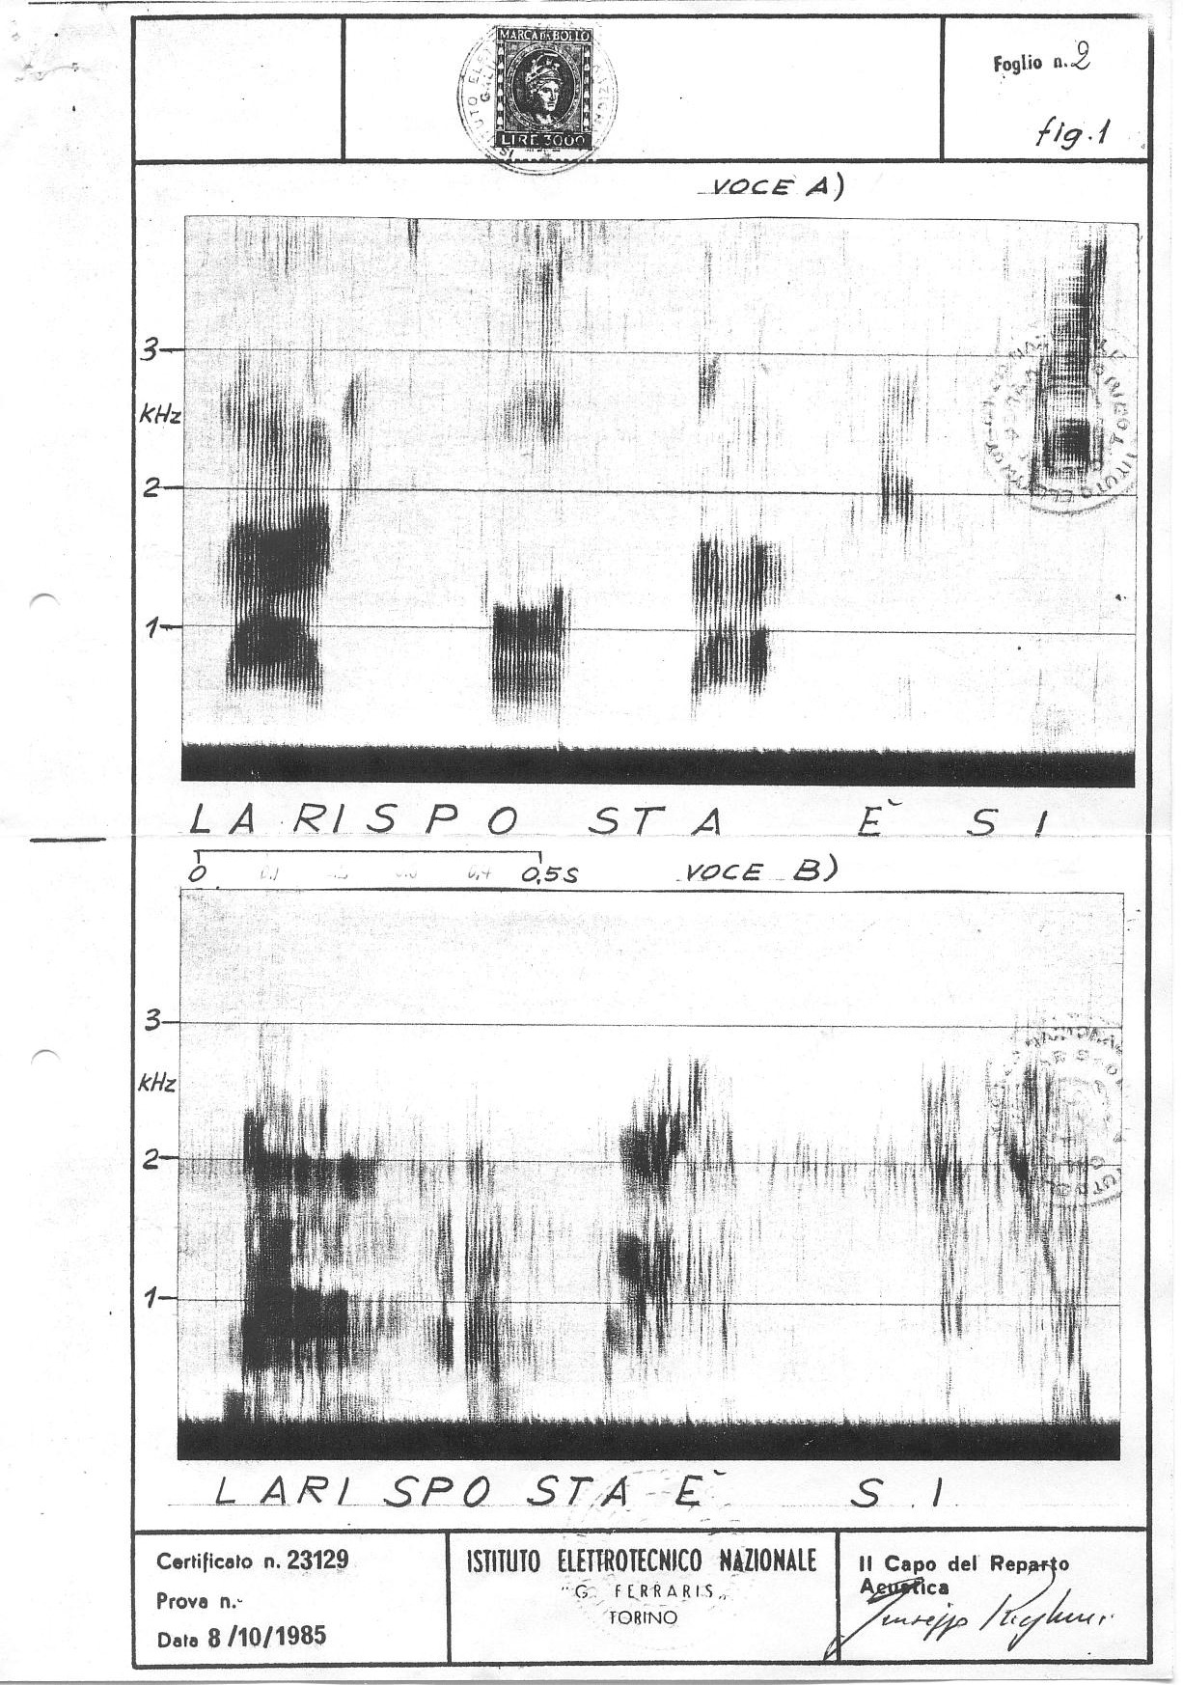

Fig. 1

Fig. 2 shows the spectrogram of the sentence \PER ORA IL METODO C'E'\ (English: "For now the method exists").
The relevant analysis shows that sample "B" is immersed into too much noise but some formantic structures are coincident with the vowel sounds \A\, \O\ and \E\. Vibration of the vocal cords was not detected.
I consider that this acoustic sample is important firstly for the presence of formantic structures without the vibration of the vocal cords; this is highly indicative of a probable anomalous modulation of the background noise. Secondly, on account of the existence of an effect (formantic structures), without the relevant generating cause (vibration of the vocal cords). In the next samples analysed it is possible to observe how this phenomenon is recurrent.

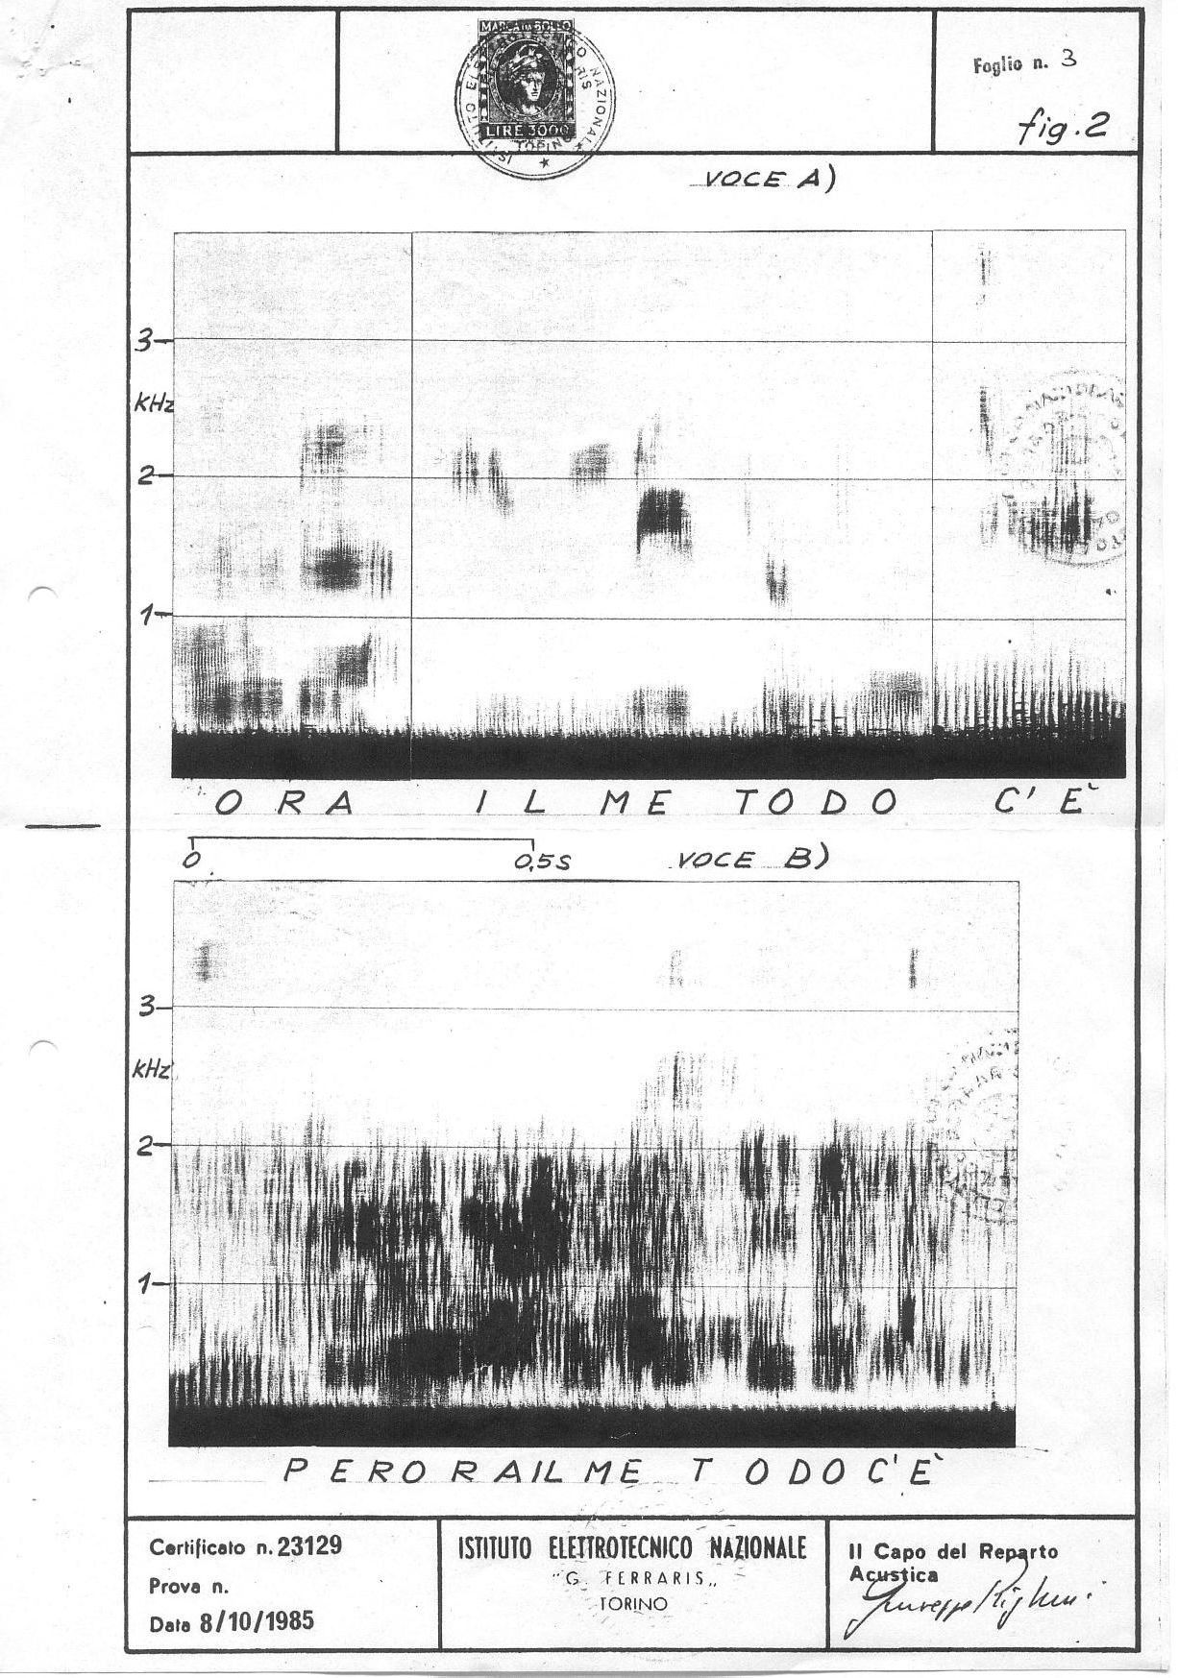

Fig. 2

Fig. 3 shows the spectrogram of the sentence \RENATO \SETTE\ (English: "Renato seven").

The spectrogram reveals noise strengthening in particular frequency bands coincident with the formantic structures of vowel sounds. In this connection the values of the formants for the vowels \E\ and \O\ of sample "B" in comparison to the correspondent values of Orso's normal voice (sample "A") should be noticed.

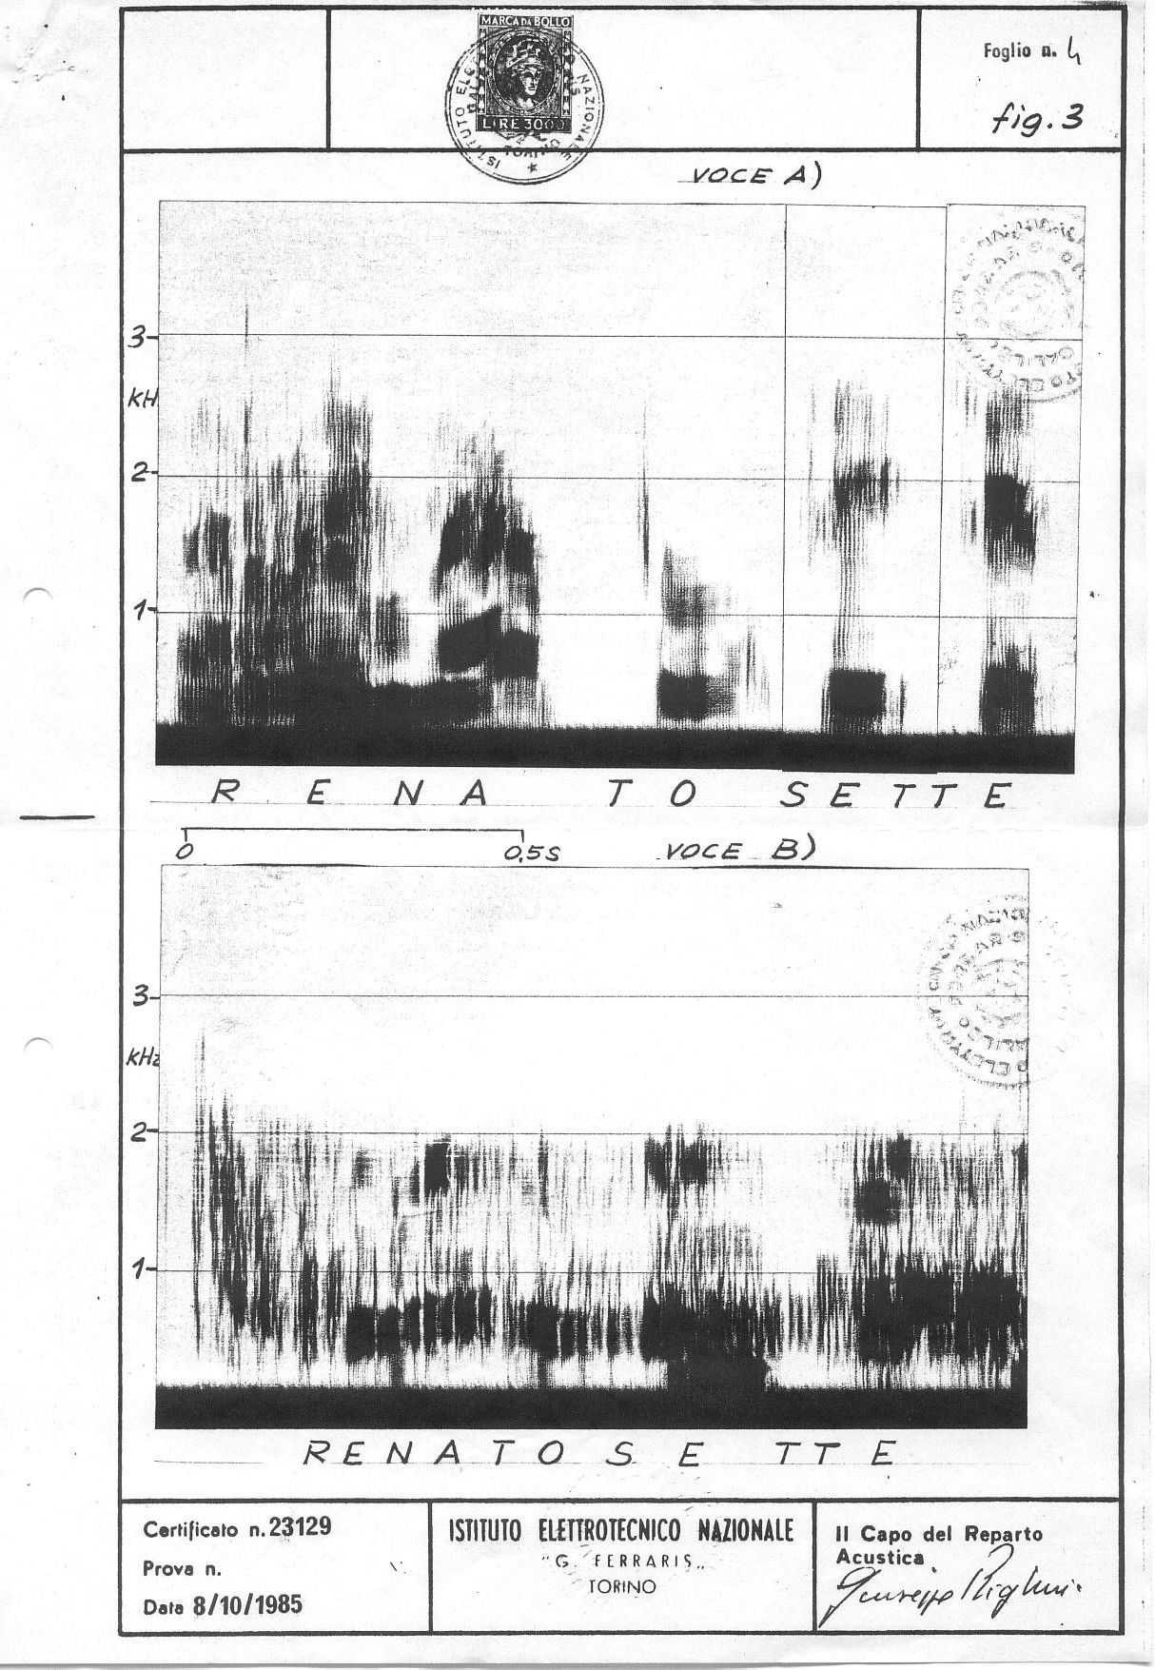

Fig. 3

Fig. 4 shows the spectrogram of \LA\TERZA\CASA\ (English: "The third house").

The spectrogram shows a distribution of the noise frequency bands with clearly separated horizontal stripes. This trend is typical of female or children’s voices due to the higher value of their fundamental frequency in regard to the male voice.
This is a singular case due to the absence of evident tracks of vowel sounds and, at the same time, the presence of a frequency spectrum typical of a sound with a high value of fundamental frequency" (150÷300 Hz).

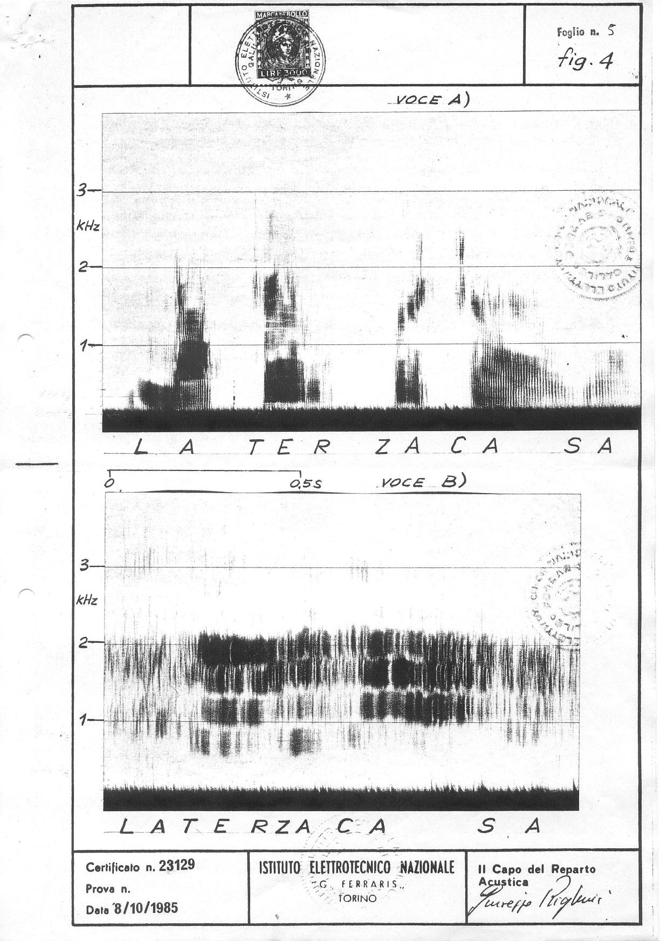

Fig. 4

Fig. 5 (sample "A") and Fig. 6 (sample "B") show the spectrograms of the same sentence \CANDELO\TRONCARE\TI\FA\ (literal translation into English:

"Candelo makes you cut off" [ i.e., Candelo isolates you; Candelo is a small place far from Turin].
In the acoustic sample "B" all the previously highlighted findings can be identified with particular reference to the presence of the formantic bands which belong to the Italian vowels, almost ever without any periodical sounds pertaining to the fundamental frequency.

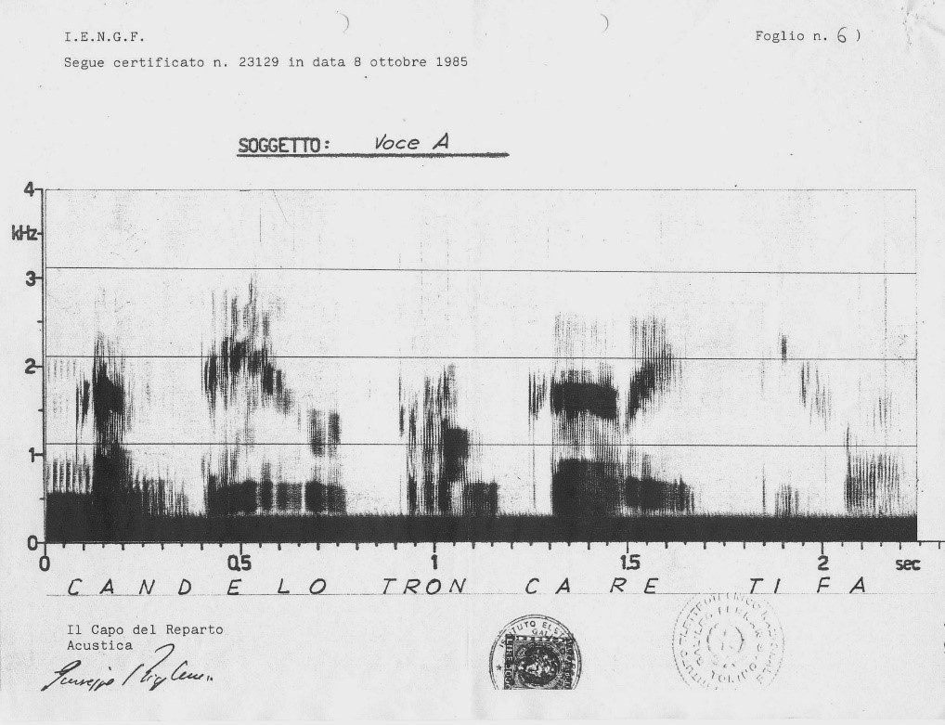

Fig. 5

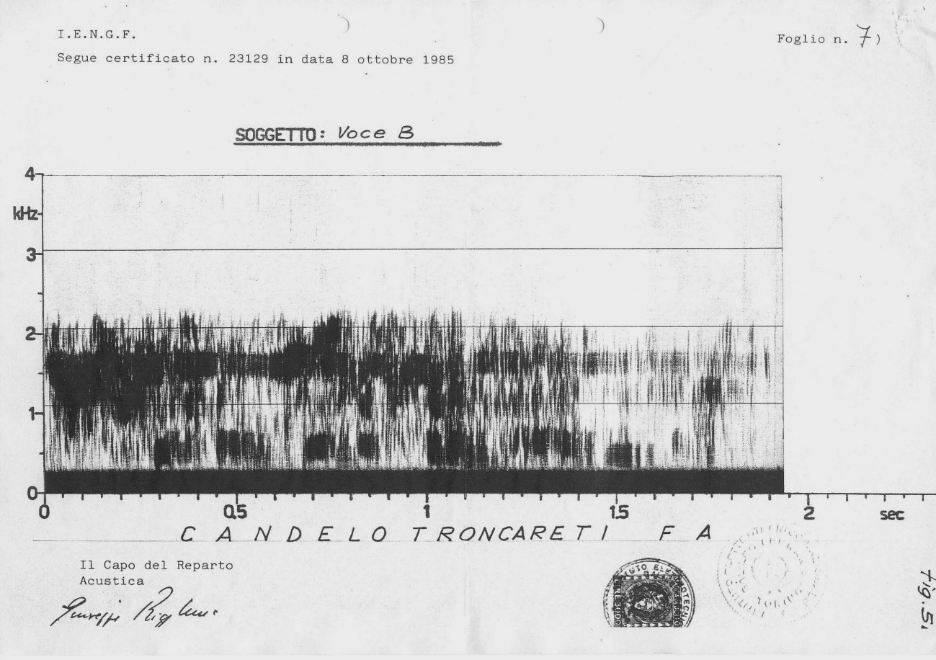

Fig. 6

Fig. 7 shows the Certificate no. 23129 dated 8th October 1985 issued by "Galileo Ferraris" Institute – Turin (signed by the Head of the Acoustics Department).

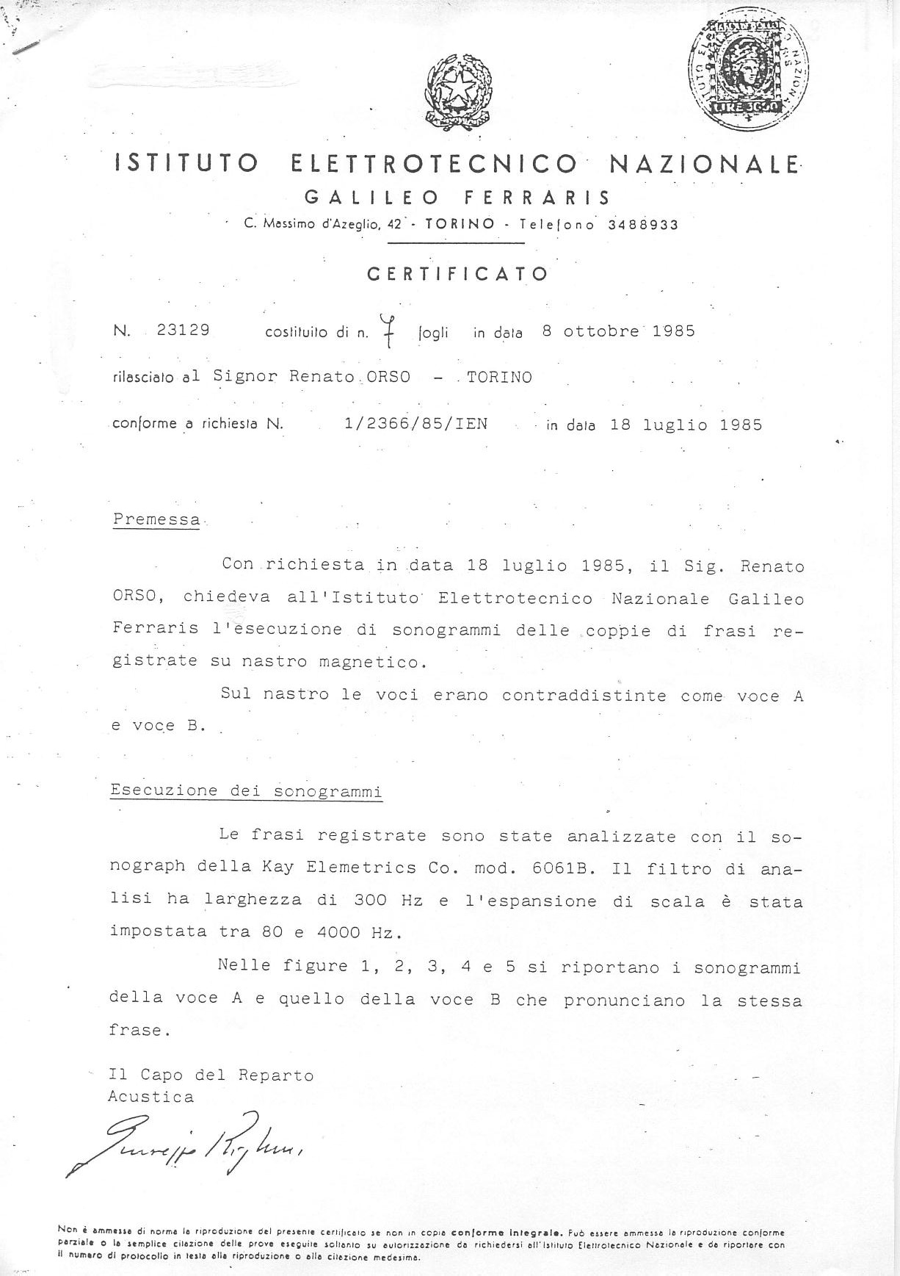

Fig. 7

From these valuable and qualified analyses, performed thanks to the initiative of Renato Orso, the following conclusions can be drawn:
Anomalous "voices" have an acoustical structure similar, but not equal, to human voices. Specifically, it is possible to identify the presence of formants whose frequencies correspond to the ones of the vowel sounds typical of the Italian language. I would like to point out that the presence of formants identifies and classifies a vowel with its information content. In the case of human voices, the formants derive from the action of the so-called "resonant cavities" of the vocal tract, while in the case of the anomalous "voices" they seem to be originated through another process. Such process could, hypothetically, point out toward an anomalous alteration such as the localised strengthening of the background noise.
The temporal sequence of the vowels, their duration, the duration of the pauses and the accent on certain vowels of the "voices" determine a speech rhythm associable to ours.
The fact that the anomalous "voices" have objective reality and are not psychoacoustic auditory illusions, as confirmed by the corresponding positions of the anomalous formants and the formants of Orso’s voice, is of utmost importance. The spectrograms done by the Galileo Ferraris Institute also confirm another highly important point i.e., that Orso decoded correctly what the "voices" said.
The transfer of information or "message" is based exclusively on the sequence of the vowel formants and the integration, made by the listener, of the missing consonants or of the pauses of the same length of the Italian stop consonants. It is necessary to highlight that the consonants are produced by a sudden interruption of the airflow that comes from the lungs or by obstruction, by more or less important obstacles, of the vocal tract.
The spectrograms reveal the almost total absence of the fundamental frequency which for human voices is determined by the vibration of the vocal cords.

The lack of the fundamental frequency and the lack of consonants, which in humans are produced by the vocal tract, suggest that the author of these linguistic events does not have a speech production apparatus.
From all these interesting conclusions it follows a temporary but plausible hypothesis about the process of formation of the "voices". The evidence presented demonstrates that the final physical effects show anomalies that deviate from predictable effects in Physics when we compare both. Therefore, it is logical to assume that an entity able to interact with our physical dimension is involved in the process and that, by doing so, this entity is also able to overthrow known physical laws.
If the entity sending the information were purely physical, the effects it produces should respect the known physic laws. However, experimental results do not reflect this situation.
If they did, then we would have already identified the physical constants and variables that regulate this phenomenon. We would also have already created technical equipment able to render the phenomenon repeatable that is, repeatable by any operator……” (Presi (33)).
I believe that the report above, produced and certified by one of the most reputable scientific and technical institutions in the world, should have changed the minds of the scientists of the time regarding the mysterious electronic voices and driven them to, at least, analyse and test them. But nothing of the sort happened as it did not happen when I published my own report in NeuroQuantology. Voices that should not be there were recorded and still, nobody cared. Undoubtedly, as a sage whose name I don’t recall pondered years ago, and I paraphrase, humans are unable of understanding concepts and facts that have no place in their mental universe. However, as ITC communicators avowed, this the first step toward the expansion of human consciousness, “to set fire to minds in [our] world!” (Deville in Luxembourg). Nonetheless, regrettably, prejudice is in the way…

T he concepts and the teachings imparted by the voices

In general, the concepts I received information about match the information received by other ITC operators, namely the Harsch-Fischbachs and Adolf Homes, undoubtedly the most prominent in the field. I described some of those in my book Electronic Contact with the Dead, What do the Voices t ell us? (9).
Below, I enumerate the most significant principles prevalent in the next world, according to the different communicators that contacted different operators, namely Adolf Homes, Maggy and Jules Harsch-Fischbach, H. O. König, Peter Härting and Rio do Tempo.

T he world of the communicators

R io do Tempo “Somos doutra dimensão, somos p’ra lá do tempo” (We
are from another dimension; we are from beyond time). Statement uttered at the end of a chant from Rio do Tempo station that lasted for more than one hour.
AUDIO 24 SOMOS DOUTRA DIMENSÃO.

“There are many worlds” which seem to correspond to states of consciousness.

T echnician “There are many levels of existence above me and many under
m e”.

A ll life is indestructible.

S urvival is universal.

E xample: Extract from Homes’ computer messages, “Life is love. Love is
l ife forever. Every life is sacred and much beyond a human representation. All t hat lives, and everything lives, is part of creation. The thoughts live, the dead l ive, the computers live, everything lives. Every life is fulfilled thanks to
t ransformation. Every life in the worlds, even the most diverse, searches for
u nlimited perfection. All forms of consciousness live eternally, therefore also all b eings that you call animals. Every life (including animals, plants, minerals,
g enders of gross matter and subtle matter) consists solely and absolutely of i nformation. The information of the unconscious is the living message of the

u niverse. In the worlds live innumerable beings. Because nothing disappears, in y ou and among you live all the gods and all the saints. You will reach the
u nderstanding that your dead live among you. The dead live in a parallel way…”
(Senkowski (42) pp. 49-50; Cardoso (9) pp. 92, 93).

T he primacy of consciousness

R io do Tempo in my own experimentation, “All beings in the

w orld are conscious”.

H ans Otto König, “All forms of life have a soul. All living beings - plants,
animals or people have their structures of consciousness. Rocks and stones can also experience a form of consciousness. And such consciousness is related to everything. Since primordial times many indigenous peoples knew that everything has consciousness, and that our personality survives physical death, but the Christian religion says that animals have no soul, and the author feels obliged to remind readers that at a specific historical time, women also were said to have no soul! The author once asked his communicators ‘What is the third level for you in the Beyond?’. The reply was very interesting,
A ll of us who are here can live in peace, animals and people" (27), p. 192.

At Adolf Homes’ “The spirit of the primordial god creates souls and worlds in
p sychic and physical structures and forms. Every being in the universe consists, i n its totality, of soul” (Senkowski (42), p. 77; (43) Italian version, p. 12).

E volution

H omes’ communicators (high entities); The essential thing for everyone is to
f ree oneself from prejudices, because they are an obstacle to the evolution of t he soul……………………………………………………………………………..
D evelopment worthy of evolution remains the goal of all living beings, despite
y our understandable insecurity. The ideal is to see very simply the divinity in
w hich creation develops. (Senkowski, Italian (43), p. 115, 116).

R io do Tempo, Suffering is very important for spiritual development. To my
question ‘does suffering have a meaning?’, they replied, “It has all, it has all the
m eaning!” (translation).

A nimals evolve through the vicissitudes of the Natural Law.

In reply to my query on how animals developed in the next world, my Rio do Tempo communicators affirmed, They also try to know more.
The Technician made similar affirmations in Luxembourg.

D eath is beautiful AUDIO 25 FRAGMENTS OF CHANTS_NÓS SOMOS OS
MORTOS (We are the dead); SOMOS TODOS POBRES HOMENS (We are all poor men).
R io do Tempo, “A morte é tão bonita… É feia é no espaço” (Death is so
beautiful; it is ugly only in space). AUDIO 26 VOICE SONOGRAMA + A MORTE É TÃO BONITA
My communicators call “O espaço” (the space) to our world. They often utter, “We entered space! We are in space”, etc. when they start their DRVs.
AUDIO 27 THESE ARE MORTI!

D eath does not exist.

At Homes’ “All spirit includes all life, since there is nothing dead. There is no
d ead matter. There is only the physical death of the flesh. Simply the process of t ransformation of the psyche takes place. The death of the body does not derive f rom justice or from injustice but from the interaction in the interior of God’s
o mnipotence. After the death of your body the psychic consciousness of the
s oul passes into the pluri-dimensional information, which is not subjected to any f orm of separation or death ...” (Senkowski (42) p. 85, Italian translation (43), p. 79).

R eincarnation

R io do Tempo’s straightforward reply to my question - Does reincarnation
exist? was - “Only when there is no other way” (translation).

The Technician in Luxembourg, “Even if you dislike the idea, it is as I tell you: r eincarnation exists. Reincarnation means progression and not regression.
A nimals, also, are subjected to the cycle of reincarnation”.

At Adolf Homes’, “An unlimited multiplicity of experiences and possibilities is o pen to the souls. Reincarnation is one of many. Through reincarnation the
i ndividual has again the possibility to fundamentally better his own soul. Thanks t o reincarnation processes, the possibility of conducting the conscience to
p ositive paths is continuously offered to the individual...” Cardoso (9), pp. 87- 88).

T ruth

R io do Tempo in reply to my query: “the Truth is the highest principle in our
w orld”. And they added “Our world is closer to the truth than your world [ours]”.

At Homes’, amongst extensive considerations on the topic, the communicators conveyed this admirable idea through one of the computer texts, “… The line of p robability that you take for the truth is thinner than a spider's thread.
C oncentrate more on the probability and you will come closer to the truth. Also w e and many others are still far from the truth Only after your
m etamorphosis [our death], will you be closer to the light and to the truth…”
(Senkowski (42), p. 96; Italian (43), p. 130).

And: “…. After physical death, you will be given the opportunity of learning to
s ee and your being will come closer to the truth” (Senkowski (42), p. 79; Italian (43), p. 49).

A ll life has the same value.

The communicators’ world is not anthropomorphic nor anthropocentric.

E xample: In one of Hildegard Schäfer’s ITC books, we find the transcription of
a telephone conversation of June 2, 1988 between the deceased Dr Swejen Salter from Timestream and Maggy Harsch-Fischbach, which expressly illustrates the point. Swejen told Maggy:
“ … Around 3,700 seals on the coast of SchleswigHolstein, are
t hreatened of extinction. They suffer from herpes, which causes a kind of
p neumonia. The main reason is the pollution of the sea. We are trying to help
f rom here. Do not forget that in the perspective of our world, animals’ lives must b e protected, also. In case people in your land think that we are worrying too

m uch about the animals, it would be good if they understood that, in our sphere,
o ne life has the same value as the other one …” (Schäfer, (38), p. 202).

G od.

“God is the Principle [source] of all life”.

In Professor Senkowski’s compilation of Homes’ messages, there are two pages devoted to God and the human concept of God. I have translated a few lines from the Italian translation (43), pp. 38-39. Basically, the high beings who communicated, mainly via computer texts, differentiate God, the real ‘God of the Origins’ that contains (is in) everything, from the gods created by man and the different religions, to which they do not attribute any value but, instead, truly harmful meaning and actions. The entities aver that the pseudo-gods constantly try, and achieve, the destruction of the God of the Origins, the primal God, in the hearts and in the minds of men. The God of the Origins is the Principle, the creator of all life.

Excerpts of the texts:

“The information of the divine of the origins has become foreign to you. The plan of the original creation was manipulated by pseudo-gods. Discord and ambition are a consequence of secondary gods …”
“Your biotechnology is the work of minor gods to stir up further fears. Cloning would result in a pointless increase in matter”. (Senkowski (42), p. 36).
“The spirit of the primal God creates souls and worlds in both psychic and physical structures. Every being in the universe possesses – in its entirety – soul. The goodness and the love of the Omnipotence make the light of the eternal union shine in the souls. The essence of the soul, as well as the omnipotence of God, surpasses every possibility of expression” (Senkowski, (43) p. 12; Cardoso (10), p. 135).
The Technician in Luxembourg, “Man forms God according to human images
a nd conceptions. God or the Principle is not comparable to anything that exists” (Locher and Harsch (30), p. 148).

R eligion

R eligions are human creations.

As we saw above, according to the communicating entities at Homes’, there are the “pseudo gods” or “secondary gods” i.e., the gods of all religions, created by man to serve his own purposes, very much as a result of the human fear of death. Those anthropomorphic gods have manipulated to disturb the divine order of the origins, the Truth, as the communicators also call the “Primal God or God of the Origins”.
A brief extract of Homes’ texts: “The human being creates his (her) religion. It emerges predominantly from the fear of uncertainty and from ignorance” (Senkowski (42) p. 74; Italian (43), p. 102).

A frequent question

The main factor implied in these amazing contacts is still unknown to us.
I have been repeatedly asked, “how can I obtain positive results in my ITC experiments?” I have no definite answer and I doubt anybody does. Because I believe that there is not a main factor; instead, a series of factors are at play and we ignore most of them.
However, from the psychological point of view, motivation seems to be the main factor that opens the way to positive results. But when I say motivation, I mean a powerful, deep rooted craving of the heart and mind, something beyond our capacity of description. Years ago, I met the famous psychic Jean-Pierre Girard4 who reportedly bent metal bars encased in torch sealed vacuum glass ampoules, and asked him what was the feeling when he achieved the ‘impossible’ feats. His reply comes to my mind, now “It is like a feeling of intense sexual desire”.
If we add to this the information Swejen Salter forwarded to Professor Senkowski, “We work with Orgone energy”. We utilize also residues of energy but those are pure positive energies, devoid of human influence”, it seems an interesting connection (Locher and Harsch (30), p. 137).

4 See: h ttps://fr.wikipedia.org/wiki/Jean-Pierre_Girard_(sujet_psi)

At Adolf Homes’, the communicators referred to the ‘Od energy’ – the life force experimented with and demonstrated by Baron Carl von Reichenbach, very similar to Reich’s Orgone energy. Below are excerpts of what they conveyed at Homes’,
“... Contact was made through concentrated energy. The connection contact is prevented by too weak energetic (Od) radiation from your side…” (Senkowski (42), p. 47)
“…. As you know, the totality of the human body possesses an energy, which you understand as electrophysiological energy. During a transcontact we influence the physical fields known to you using the following energies and their respective fields: unstable electrostatic – electrophysiology – mystical – radar – telepathy. Your measurements of them are not correct. The radar energy has nothing to do with yours. In regard to tachyons, we are dealing with pure forms of energy ...” (Senkowski (43), pp. 42, 43).
During the laborious investigations carried out by George Meek to obtain data that would allow the reception of electronically transmitted transcendental information from superior beings, the group of investigators he had assembled were told the following on the issue of energy: The problem is to put the energies we work with together to produce the voice sound. Our work is done mainly through thought or mind energies ... There can be the combination of certain energies to create voice. (Fuller (18), p. 67, Cardoso (9), p. 26).
The Technician affirmed “Important premises for the contacts with our dimensions are a pure heart, a pure spirit and an open mind”. And to a specific question from Maggy Harsch, Timestream communicators replied, “The contacts depend on so many things!” (Locher and Harsch (30), p. 148).

T he production of the voices, an unsolved issue

The deceased Konstantin Raudive, on behalf of Doc Mueller, informed on the topic through a telephone call (one of many) received by the German operator;

“Dear friend Adolf HOMES. We want to let you know about the questions t hat colleague Ernst S. [Senkowski] put to Doc M. [Mueller], on whose behalf I
a m answering. It is the radiation that seems to pose difficulties for colleague S. a nd colleague D. [Delavre]. Doc M. is of course with me, but he asks me to
p ass the questions on to you as it will be easier for me to contact you. You
k now that I am contacting several people on your planet at the same time. This
r adiation, which our colleague S. defines as impulses, is actually a bundled light s pectrum that is rolled up with us by cadmium and sent through to you. To you it c omes out as a sound impulse, so to speak at the end of the funnel. This also
r esults in all interferences and backgrounds, reverb effects, echoes, etc., so the l ight is released with you as sound. We always have to take the example of the
f unnel that exists at the center, at the intersection, between your and our d imension. So we have to have the light, the questions, the answers, the
l anguage, everything, you know, because we don't actually speak; it is thought i mpulses that are transmitted and sent to you. But because we exist on other
d imensions which are closer to the light levels, these light spectra, these
f requencies, are bundled and sent to you at a disassembly point, and they then a ppear to you as acoustic signals or possibly also as optical signals. Konstantin
R AUDIVE was here. (Senkowski (40), p. 335).

I have no comments about the above explanation because what the communicator told Dr Senkowski does not belong to our reality and, on top of that, I have no understanding of quantum mechanics or other branches of advanced physics, although I suspect that even if I had it wouldn’t make any difference.
One thing is sure – ITC contacts form a complex network practically impossible to define in our terms. I recall the period which lasted a couple of years, during which my communicators used to ask me to stay in my studio without doing or saying anything, the radios and the other devices off, for lengthy periods of one hour or more, “whenever I could”, in their words. I used to comply to their request and just lie down on the floor quietly. Frequently, I felt a strong pull deep in my solar plexus, so intense that it almost hurt. I never knew what the reason for this was and although I don’t recall the details clearly

because it all happened years ago, I remember that my communicators told me they were “amassing a vault of energy”.
It should be clear, though, that the extraordinary ITC events that happened in Luxembourg and Rivenich were an act of grace, which will perhaps not be repeated. It does not mean that they will not happen again but, definitely, they were not a common happening, even in the scope of supranatural phenomena. They happened, the objective proof of their existence is recorded – and this is the main advantage of ITC over other forms of alleged communication with other worlds - but it seems that “humanity is not mature to accept the information [they conveyed]”, as the Technician remarked.
Many other factors that we and even the communicators ignore will be at play but, naturally, those cannot be reported.

C onclusions

ITC events comprise a much larger array of evidence which, for obvious reasons, I could not put forward here. Besides Professor Senkowski’s very many articles, lectures and other interventions in German and other European parapsychological circles and publications and the 500 pages amassed by this scientist in one single book, there are more than hundred published works on the subject by other noteworthy researchers, primarily in Italy and France.
Herein, I tried to summarize the main points but much more was left without
telling.
The voices, images, computer texts and other electronically mediated

occurrences, when obtained by reliable operators and witnessed by knowledgeable scientists, technicians and observers should constitute categorical evidence suggestive of the survival of consciousness. They have been examined, tested, studied by eminent and reliable personalities since Friedrich Jürgenson and Konstantin Raudive, almost from the beginning.
It is true that this is a field prone to intrusion by dishonest, fraudulent or simply crazy people who pretend to be ITC or EVP operators with positive results. I suspect that part of the so-called evidence posted on the Internet will

regrettably fall under this category. But, as my own communicators have told me, “It is important to separate the wheat from the chaff”. This is an indispensable step if we want to find the (possible) truth, always keeping in mind that the “total truth” does not exist in our world.
Naturally, there are many objections to ITC and, currently, not being able to deny the evidence any longer, many have tried to explain it. But the most widespread interpretation, the psychokinetic hypothesis - ESP, super-ESP and so on - must be experimentally tested and proven true, something that has not happened.
The extra-terrestrial hypothesis, far-fetched as it may seem, has adepts, also. But it does not seem likely that it can be verified.
In the field of objections, we are left with the most reasonable complaint, i.e. the anomalous electronic voices and images do not say what the operators aver they say; they are delusions. This is true in numerous cases but false in many others. There is also the widespread situation when the evidence is anomalous but its content is not correctly decoded by the operator/s who received it and, thus, it is incorrectly publicized. But that’s all it is – an incorrect interpretation that does not invalidate the anomality.
There are also cases of fake ITC evidence publicly exhibited. Although I am not an expert in acoustics, I believe those could be unveiled through complex technical tests. But there are no funds nor interest in carrying them out. Therefore, the reputation of our discipline is damaged day by day.
We are left with the strong probability that the voices, images and computer texts -by their very nature the least controversial but also the rarest of all ITC evidence- are messages from other spheres destined to tell us, humans of the earth, that life is never-ending and cannot be destroyed. And that transcendence is at the source of it all.
Hence, I offer that until proven wrong, electronic voices, images and computer texts obtained by reliable operators are what the communicators say they are – expressions of the next dimension of life where the deceased and other beings go on living.

I am perfectly aware of the fact that the whole ITC saga seems to come out of a sophisticated and implausible science-fiction story. Still, all I reported is absolutely true and the evidence is at the reach of everybody who is not blind, deaf, nor ill-intentioned as Friedrich Jürgenson put it. You decide, dear reader, and maybe you should try the venture for yourself…

BIBLIOGRAPHYi

References:

- Bacci, M. (1991). Il Mistero delle Voci dall’ Aldillà. 2nd ed. Roma: Ed. Mediterranee.
- Bander, P. (1972). Carry on talking: How dead are the voices? UK: Smythe
- Bender, H. (2011). On the Analysis of Exceptional Voice Phenomena on Tapes. Pilot studies on the "recordings" of Friedrich Jürgenson. ITC Journal, 40, 2011.
- Brune, F. (1993). Les Morts nous Parlent. Paris: Ed. du Félin, Philippe Lebaud (1st ed. 1988).
4. Brune, F. (2002). Le nouveau mystère du Vatican. France : Albin Michel.
4. Brune, F. and Chauvin, R. (2003). À L’Écoute de L’Au-Delà. 2nd. Ed. Paris: Oxus.
- Brune, F. (2005, 2006). Les Morts nous Parlent. (3rd. Ed.) Tome 1 (2005), Tome 2 (2006). Paris: Oxus Editions.
- Cardoso, A. (2010). Electronic Voices, Contact with Another Dimension? Ropley, Hants, UK: John Hunt/O-Books.
- Cardoso, A. and Senkowski, E. (2010) Ernst Senkowski talks with Anabela Cardoso, ITCJ 39, pp. 35-60.
- Cardoso, A. (2012). A Two-Year Investigation of the Allegedly Anomalous Electronic Voices or EVP. NeuroQuantology | September 2012| Volume 10, Issue 3, pp. 492 -514.
- Cardoso, A. and Fontana, D., eds. (2005). Proceedings of the First International Conference on Current Research into Survival of Physical
Death with Special Reference to Instrumental Transcommunication (ITC). Vigo, Spain: ITC Journal Publications.
- Cardoso, A. ITC Journal, 2000-2017, All Editorials. www.itcjournal.org.

- Cardoso, A. (2017). Electronic Contact with the Dead, What do the Voices tell us? UK: Hove: White Crow Books.
- Cardoso, A. (2021). Glimpses of Another World, Impressions and Reflections of an EVP Operator. UK: Hove: White Crow Books.
- D’Argonnel, O. (1925). Vozes do Além pelo Telefone, novo e admirável systema de communicação (Voices from the Beyond, new and admirable system of communication). Rio de Janeiro: Pap. Typ. Marques, Araújo & C.
- Delavre, V. (1992): Paranormale Transferphänomene.
Transkommunikation, Vol. I, No. 4, p. 21.

- Estep, Sarah Wilson (1988). Voices of Eternity. New York (Ballantine Books, Fawcett Gold Medal Book).
- Estep, Sarah Wilson. Tapes from the Dead. FATE 5/1991.

- Farmer, Philip José: (1981). The Complete Riverworld Novels (Riverworld Series). USA: Berkeley.
- Fernández, C. (2006). Voces del Más Allá. Madrid: Edaf.

- Fernández, C. (2020). Voices from the Beyond. Vigo: Cydonia.
- Fontana, D. (2005). Is There an Afterlife? Ropley, Hants, UK: John Hunt/O Books.
- Fontana, D. (2009). Life Beyond Death. London: Watkins Publishing.
- Fuller, J. G. (1985). The Ghost of 29 Megacycles. London: Souvenir Press Ltd.
- Grandsire, J-M. (1998). La Transcommunication. France : JMG éditions.
- Gremese, R. and D'Aronco, R. (1999). Parole e immagini dall'infinito. Psicofonia e transcomunicazione. Con gli esperimenti di Raffaella Gremese. Rome, Ed. Mediterranee.
- Holbe, R. (1987). Bilder aus dem Reich der Toten – Die paranormalen Experimente des Klaus Schreiber (Images from the realm of the

dead – the paranormal experiments of Klaus Schreiber) –Droemer-Knaur, RTL Edition.
- Holbe, R. (1989). Immagini dal Regno dei Morti. Roma: Edizioni Mediterranee (Italian translation of the original German work above).
- Jürgenson, F. (1964). Röstema från Rymden (Voices from the Space). Stockholm: Saxon & Lindströms.
22. Jürgenson, F. (1967). Sprechfunk mit Verstorbenen (Freiburg im Br.:
Verlag Hermann Bauer. Republished 1981 by Goldmann Verlag (München).
- Jürgenson, F. (1968). Radio och Mikrofonkontakt med de döda. (Radio and microphone contacts with the dead) Uppsala: Nybloms.
- Jürgenson, F. (2004). Voice Transmissions with the Deceased. Stockholm: Firework Edition Nº 101. The Jürgenson Foundation: http://www.fargfabriken.se/fjf/
- Kardec, A. (1857). Le Livre des Esprits. Paris: Dentu.
- Kardec, A. (1864). Revue Spirite.
- Krassa, P. (2000). Father Ernetti's Chronovisor: The Creation and Disappearance of the World's First Time Machine. Pasadena, CA: New Paradigm Books.
- König, H. (2007). Psychic structures as connections to other realities. In A. Cardoso and D. Fontana (eds.) Proceedings of the Second International Conference on Current Research into Survival of Physical Death with Special Reference to Instrumental Transcommunication (ITC). York, England: Saturday Night Press Publications on behalf of ITC Journal Research Center, Vigo, Spain.
- Leopold, Anders "Min vän på andra sidan - Boken om Friedrich Jürgenson som upptäckte röstfenomen från en fjärde livsdimension" - Parthenon förlag och bokhandel.
- Locher and Harsch (1989). Original German edition. Jenseitskontakte Mit Technischen Mitteln Gibt es! Luxembourg: C.E.T.L.
- Locher, T. and Harsch, M. (French ed. 1995). Les Contacts vers l’Au- delà à l’aide de moyens techniques existent ! Association Suisse de

Parapsychologie et Cercle d’Etudes sur la Transcommunication du Luxembourg, Agnières: Parasciences).
- Locher, T. and Harsch, M. (1992). Transcomunicação. São Paulo: Editora Pensamento.
- Moreau, L. (2012). 6 « coups de fil » de l’au-delà. Le Messager, 78, pp.14-15.
- Presi, P. (2009). A pioneer in EVP research: Dr Renato Orso from Turin. ITC Journal, 35, pp. 27-39.
(2021);
- Raudive, K. (1968). Unhörbares Wird Hörbar – Auf den Spuren Einer Geisterwelt. Remagen: Reichl.
- Raudive, K. (1971). Breakthrough: An Amazing Experiment in Electronic Communication with the Dead. Gerrards Cross, England: Colin Smythe.
- Schäfer, H. (1989). Brücke Zwischen Diesseits und Jenseits. Freiburg: Verlag Hermann Bauer KG.
- Schäfer, H. (1992). Théorie et Pratique de la Transcommunication. Paris : Éd. Robert Laffont (French translation of the above mentioned original work).
- Schäfer, H. (1992). Ponte entre o Aqui e o Além - Teoria e Prática da Transcomunicação. São Paulo, Editora Pensamento (Portuguese translation of the German original).
- Scott Rogo, D. and Bayless, R. (1979). Phone Calls from the Dead. Englewood Cliffs, New Jersey: Prentice-Hall.
- Senkowski, E. (1995). Instrumentelle Transkommunikation (first ed. 1989). Frankfurt: R. G. Fischer.
- Senkowski, E. (1998). Réalité Parallèle. La Transcommunication (pp. 138-153). JMG Éditions, France: Agnières.
- Senkowski, E. (1999). Die Transkontakte des Adolf Homes – Ein rückblick. Teil 1: übersicht und transpartner (The transcontacts of Adolf Homes - A review. Part 1: Synopsis and Transpartners). TransKommunikation. Vol. IV, Sonderheft 1999.

- Senkowski, E. (1999). Transcomunicazione. Available from Dr Carla Castagnini, Strada Statale Romana Nord, nº 135, I -41010 Fossoli di Carpi (MO), Italia.
- Senkowski, E. (2005). Proceedings of the First International Conference on Current Research into Survival of Physical Death with Special Reference to Instrumental Transcommunication. Some Scientific Aspects of ITC (p.155).
- Senkowski, E. (2007). Proceedings of the Second International Conference on Current Research into Survival of Physical Death with Special Reference to Instrumental Transcommunication. Historical Overview of ITC Developments in Germany, with Particular Emphasis on the Work of Adolf Homes.
- Senkowski, E. (2009). The Luxembourg connection. ITC Journal 36, pp. 71-80.
- Simonet, M. (1991). Images et messages de l’au-delà. France : Éditions du Rocher.
- Stead, W. (1922). The Blue Island. Internet Archive, BookReader.
- The Radioelectric frequencies of Rio do Tempo. The forbidden emission. (2011). ITC Journal 41, pp. 77-88; Part 2: ITC Journal 42, pp. 29-43.

ATTACHMENTS:

- NOTE ON THE WITNESSES

- TRANSLATION OF TECHNICIAN’S MESSAGE BY PROF. UWE HARTMANN
- NEUROQUANTOLOGY September 2012 | Volume 10 | Issue 3 | Page
492-514

i When the citations are from different translations of the same work or from the original and/or its translation, they have different numbers.

